|  |  |
| --- | --- |
|  | **FPT ACADEMY INTERNATIONAL**  **FPT – APTECH COMPUTER EDUCATION** |

**Centre Name: ACE-HCMC-2-FPT.**

**Address: 590 Cach Mang Thang 8, District 3, Ho Chi Minh City, Viet Nam.**

Ice Cream Shop Management System

|  |  |  |
| --- | --- | --- |
| **Supervisor:** | Ms. Le Mong Thuy | |
| **Semester:** | 3 | |
| **Batch No:** | T1.1804.M1 | |
| **Group No:** | 5 | |
| **Order:** | **Full name** | **Roll No.** |
| 1. | Bui Van Huong | Student1093630 |
| 2. | CHAU THANH PHONG | Student1088413 |
| 3. | DANG NGUYEN DAN LINH | Student1053724 |
| 4. | LY TIEN DAT | Student1093706 |
| 5. | MAI HOANG MINH TIEN | Student1057354 |

Month: July Year: 2019

Contents

REVIEW 3 2

I. DATABASE DESIGN 3

**1.** **Database Design Diagram** 3

**2.** **Database Structure** 4

**2.1.** **Table Admin** 4

**2.2.** **Table Customer** 4

**2.3.** **Table Feedback** 4

**2.4.** **Table Category** 4

**2.5.** **Table Product** 5

**2.6.** **Table Recipes** 5

**2.7.** **Table Order** 5

**2.8.** **Table InvoiceDetailBook** 6

II. GUI DESIGN 7

**1.** **User Interface** 7

**1.1.** **Home Page:** Introduce the website with the navigation bar links. 7

**1.2.** **Contact Us Page:** Show contact information of clinic & feedback form for user. (must login first to send feedback) 11

**1.3.** **Login Page:** Login form for user 14

**1.4.** **Logout:** notification will appear when admin click logout button 17

**1.5.** **Register Page:** Register form for user if they haven’t account. 18

**1.6.** **Change Personal Information Page:** User can change their information here. 21

**1.7.** **Update Password Page:** User can change their Password here. 24

**1.8.** **Register Member Page:**If the user is not register ,user can fill value member is this profiles. 27

**1.9.** **Book Page:** This page display list of medicines, user can search item with search bar. 29

**1.10.** **Product Details Page:** This page display information of a product. User 32

also can add this product to cart 32

**1.11.** **Free Recipes:** This page display list of recipes for your user don’t use account. 34

**1.12.** **Full Recipes:** This page display list of recipes for your user register a member as month or year 37

**1.13.** **Detail of Recipes:** This page display the way to cook this favourite ice cream. 39

**1.14.** **FAQ Page:** This page display list of frequently of question. 41

**1.15.** **Your Cart Page:** Items which user had chosen will display here. 43

**1.16.** **Checkout page:** This page show for user confirm payment. 46

***1.17.******InvoiceDetailBook:*** *this page display information about order user just bought 50*

***1.18.******Details of an order:*** *when user click details button in order details page, it will show details of it. 52*

**1.19.** **Personal order history:** this page display history all orders of personal user. User can view it by click to menu “Order History” appears when user login successfully. 54

***2.******Admin Interface:*** *58*

**2.1.** **Login Page**: Login form for admin (default: Username: **admin**, password: **123456**) 58

**2.2.** **Logout:** notification will appear when admin click logout button 60

**2.3.** **Change Password Page:** Admin can change password here 61

**2.4.** **Home Page:** has navigation bar links to all manage pages 63

**2.5.** **Category Management Page:** Admin can manage product here 64

**2.6.** **Product Management Page:** Admin can manage product here 72

**2.7.** **User Management Page:** Admin can manage user here 82

**2.8.** **Order Management Page:** Admin can manage order here 88

**2.9.** **Feedback Management Page:** Admin can manage feedback here 93

**2.10.** **Recipes Manage Page:** Admin can manage recipe in here 97

*3. SITE MAP 106*

*1. TEST PLAN/TEST CASE 108*

*2. CHECKLIST OF VALIDATIONS 109*

*3. SUBMISSION CHECKLIST 110*

*TASK SHEET REVIEW 3 111*

# REVIEW 3

1. **DATABASE DESIGN**
2. **Database Design Diagram**

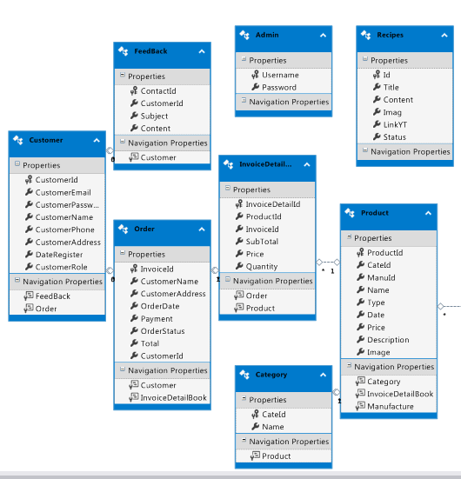

1. **Database Structure**
   1. **Table Admin**

|  |  |  |  |  |  |  |  |
| --- | --- | --- | --- | --- | --- | --- | --- |
| **No** | **Field Name** | **Data Type** | **Null** | **Default** | **Key** | **Reference Table** | **Description** |
| 1 | Username | varchar(20) | No | **admin** | PK |  | Admin’s Username |
| 2 | Password | varchar(20) | No | **123456** |  |  | Admin’s Password |

* 1. **Table Customer**

|  |  |  |  |  |  |  |  |
| --- | --- | --- | --- | --- | --- | --- | --- |
| **No** | **Field Name** | **Data Type** | **Null** | **Default** | **Key** | **Reference Table** | **Description** |
| 1 | CustomerId | int | No | Identity(1,1) | **PK** |  | User’s ID |
| 2 | CustomerPassword | varchar(50) | Yes |  |  |  | User’s Password |
| 3 | CustomerName | varchar(50) | Yes |  |  |  | User’s Name |
| 4 | CustomerPhone | varchar(100) | Yes |  |  |  | User’s Phone |
| 5 | CustomerAddress | datetime | Yes |  |  |  | User’s Address |
| 6 | DateRegister | varchar(50) | Yes |  |  |  | User’s Date Regist |
| 7 | CustomerRole | tinyint | Yes |  |  |  | User’s Role |
| 8 | CustomerEmail | varchar(50) | Yes |  |  |  | User’s Email |

|  |  |  |  |  |  |  |  |
| --- | --- | --- | --- | --- | --- | --- | --- |
| **No** | **Field Name** | **Data Type** | **Null** | **Default** | **Key** | **Reference Table** | **Description** |
| 1 | ContactId | int | No | Identity(1,1) | PK |  | Feedback’s ID |
| 2 | CustomerId | Int | No |  | **FK** | User(ID) | User’s ID |
| 3 | Subject | varchar(500) | No |  |  |  | Feedback’s Subject |
| 4 | [Content] | varchar(30) | No |  |  |  | Feedback’s Content |

* 1. **Table Feedback**
  2. **Table Category**

|  |  |  |  |  |  |  |  |
| --- | --- | --- | --- | --- | --- | --- | --- |
| **No** | **Field Name** | **Data Type** | **Null** | **Default** | **Key** | **Reference Table** | **Description** |
| 1 | CateId | Int | No | Identity(1,1) | PK |  | Category’s ID |
| 2 | Name | varchar(50) | No |  |  |  | Category’s Name |

* 1. **Table Product**

|  |  |  |  |  |  |  |  |
| --- | --- | --- | --- | --- | --- | --- | --- |
| **No** | **Field Name** | **Data Type** | **Null** | **Default** | **Key** | **Reference Table** | **Description** |
| 1 | ProductId | int | No | Identity(1,1) | PK |  | Product’s ID |
| 2 | CateId | int | No |  | FK | Category (CateId) | Category’s ID |
| 3 | ManuId | int | No |  | FK | Manufacture (ManuId) | Manufacture’s ID |
| 4 | Name | varchar(50) | No |  |  |  | Product’s Name |
| 5 | Type | varchar(50) | No |  |  |  | Product’s Type |
| 6 | Date | datetime | No |  |  |  | Recipe Date |
| 7 | Price | double | No |  |  |  | Product’s Price |
| 8 | Description | varchar(1000) | No |  |  |  | Product’s Description |
| 9 | Image | varchar(50) | No |  |  |  | Product’s Image |

* 1. **Table Recipes**

|  |  |  |  |  |  |  |  |
| --- | --- | --- | --- | --- | --- | --- | --- |
| **No** | **Field Name** | **Data Type** | **Null** | **Default** | **Key** | **Reference Table** | **Description** |
| 1 | Id | int | No | identity(1,1) | PK |  | Recipe’s ID |
| 2 | Title | varchar(100) | Yes |  |  |  | Recipe’s Ttile |
| 3 | [Content] | text | Yes |  |  |  | Recipe’s Content |
| 4 | Imag | text | Yes |  |  |  | Recipe’s Image |
| 5 | LinkYT | text | Yes |  |  |  | Recipe’s Link |
| 6 | Status | varchar(10) | Yes |  |  |  | Recipe’s Status |

* 1. **Table Order**

|  |  |  |  |  |  |  |  |
| --- | --- | --- | --- | --- | --- | --- | --- |
| **No** | **Field Name** | **Data Type** | **Null** | **Default** | **Key** | **Reference Table** | **Description** |
| 1 | InvoiceId | int | No | Identity(1,1) | PK |  | Order’s ID |
| 2 | CustomerId | int | No |  | FK | Customer(CustomerId) | Customer’s ID |
| 3 | CustomerName | varchar(50) | No |  |  |  | Order’s Customer Name |
| 4 | CustomerAddress | varchar(50) | No |  |  |  | Order’s Customer Address |
| 5 | OrderDate | datetime | No |  |  |  | Order Date |
| 6 | Payment | varchar(20) | No |  |  |  | Payment |
| 7 | OrderStatus | bit | No |  |  |  | Order Status |
| 8 | Total | int | No |  |  |  | Total |

* 1. **Table InvoiceDetailBook**

|  |  |  |  |  |  |  |  |
| --- | --- | --- | --- | --- | --- | --- | --- |
| **No** | **Field Name** | **Data Type** | **Null** | **Default** | **Key** | **Reference Table** | **Description** |
| 1 | InvoiceDetailId | int | No | identity(1,1) | PK |  | OrderDetails’s ID |
| 2 | InvoiceId | int | No |  | FK | Order (OrderId) | Order’s ID |
| 3 | ProductId | int | No |  | FK | Product (ProductId) | Product’s ID |
| 4 | Price | double | No |  |  |  | Product’s Price |
| 5 | Quantity | int | No |  |  |  | Product’s Quantity |
| 6 | SubTotal | double | No |  |  |  | Product’s Sub Total |

1. **GUI DESIGN**
2. **User Interface**
   1. **Home Page:** Introduce the website with the navigation bar links.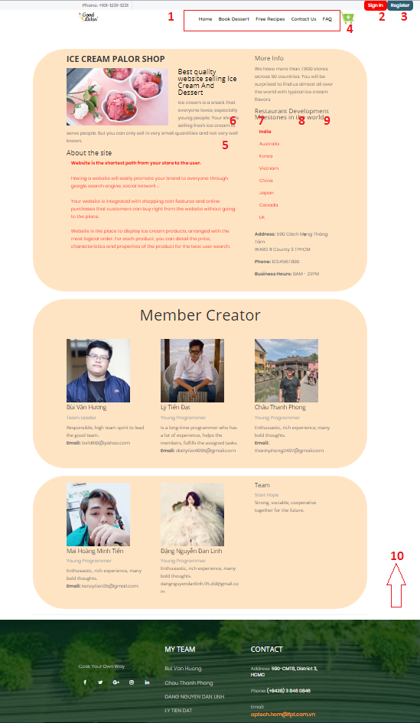

|  |  |  |  |  |  |  |
| --- | --- | --- | --- | --- | --- | --- |
| **No** | **Name** | **Type** | **Source Code** | **Event** | **Description** | **Status** |
| 1 | Navigation Bar | Hyperlink | Figure 1 | Click | Choose & click to go to sub pages | Enable |
| 2 | Login | Hyperlink | Click | Click to go to login page | Enable |
| 3 | Register | Hyperlink | Click | Click to go to register page | Enable |
| 4 | Cart | Hyperlink | Click | Click to go to cart page | Enable |
| 5 | Form About Us | TextBox | Figure 2 | Focus | Information about website | Enable |
| 6 | Book Dessert | Hyperlink | Figure 1 | Click | Click to go to Book product page | Enable |
| 7 | Free Recipes | Hyperlink | Click | Click to go to Recipes page(login to see Full Recipes) | Enable |
| 8 | FAQ | Hyperlink | Click | Frequently asked questions | Enable |
| 9 | Conatct | Hyperlink | Figure 1 | Click | Send feedback | Enable |
| 10 | Footer | Hyperlink | Figure 3 | Click | Some information to contact with clinic | Enable |

**Source code:**

**View:**

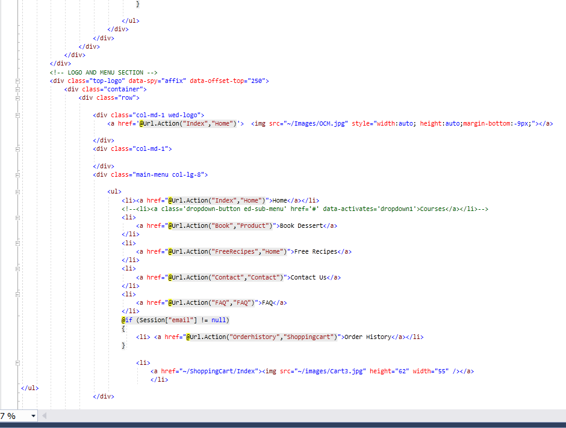

Figure

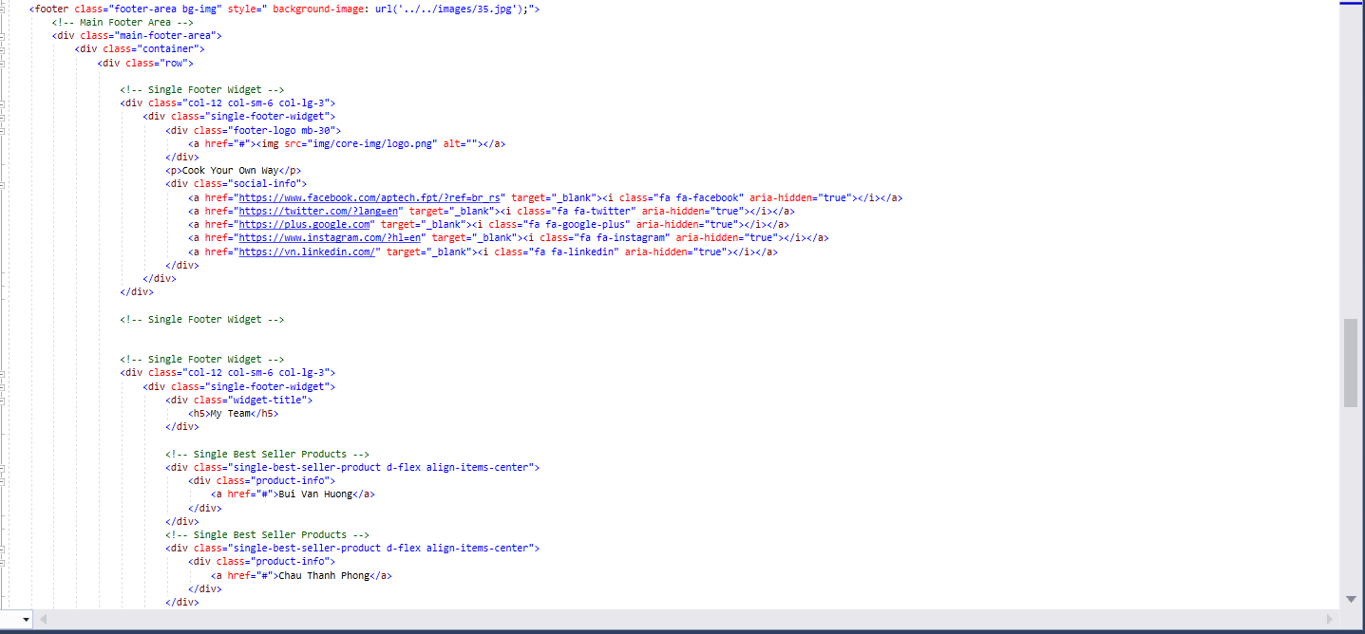

Figure



Figur

* 1. **Contact Us Page:** Show contact information of clinic & feedback form for user. (must login first to send feedback)

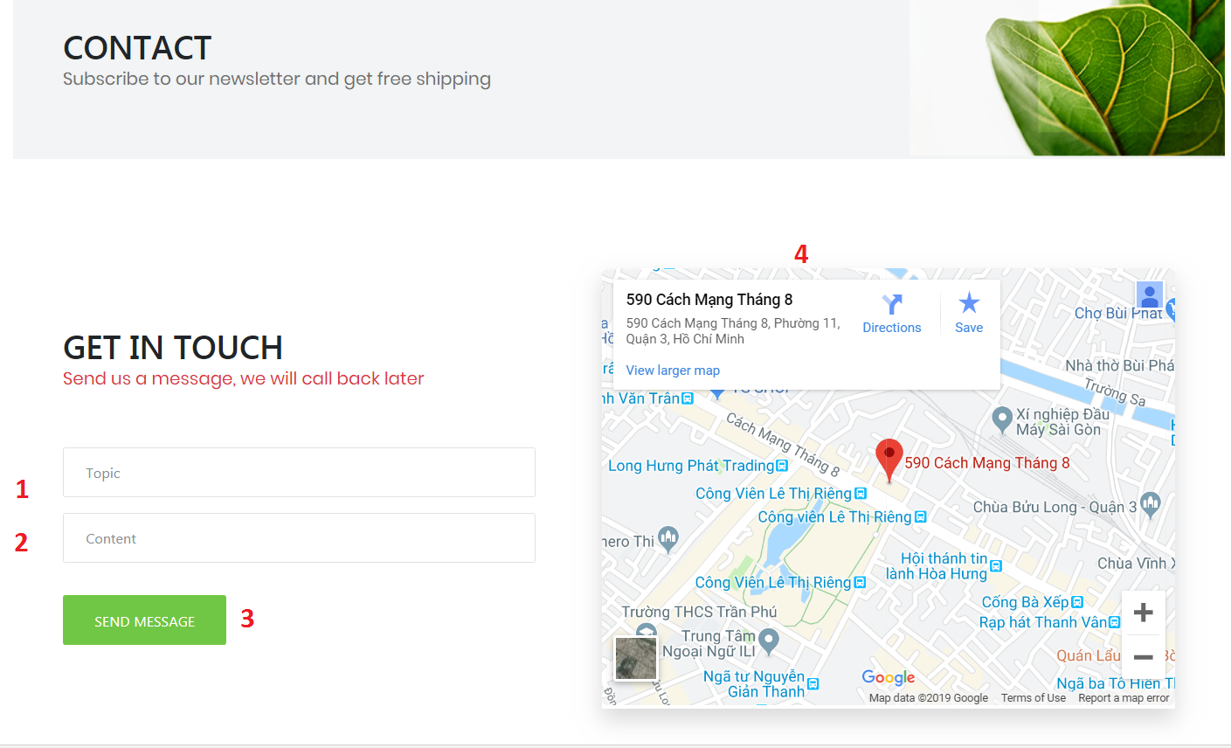

|  |  |  |  |  |  |  |
| --- | --- | --- | --- | --- | --- | --- |
| **No** | **Name** | **Type** | **Validation** | **Event** | **Description** | **Status** |
| 1 | Subject | Textbox | - Not null - Max length:50 | Focus | Input feedback’s subject | Enable |
| 2 | Message | Textbox | - Not null - Max length:500 | Focus | Input feedback’s content | Enable |
| 3 | Send Message | Button |  | Click | Click to send feedback | Enable |
| 4 | Map |  |  |  | Location of My Store | Enable |

If send feedback successfully, a notification will appear, click to go back contact page:

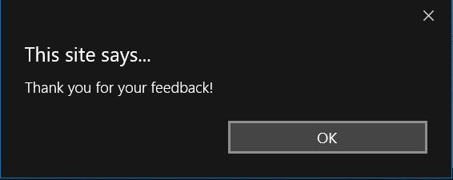

**Source code:**

**Controller:**

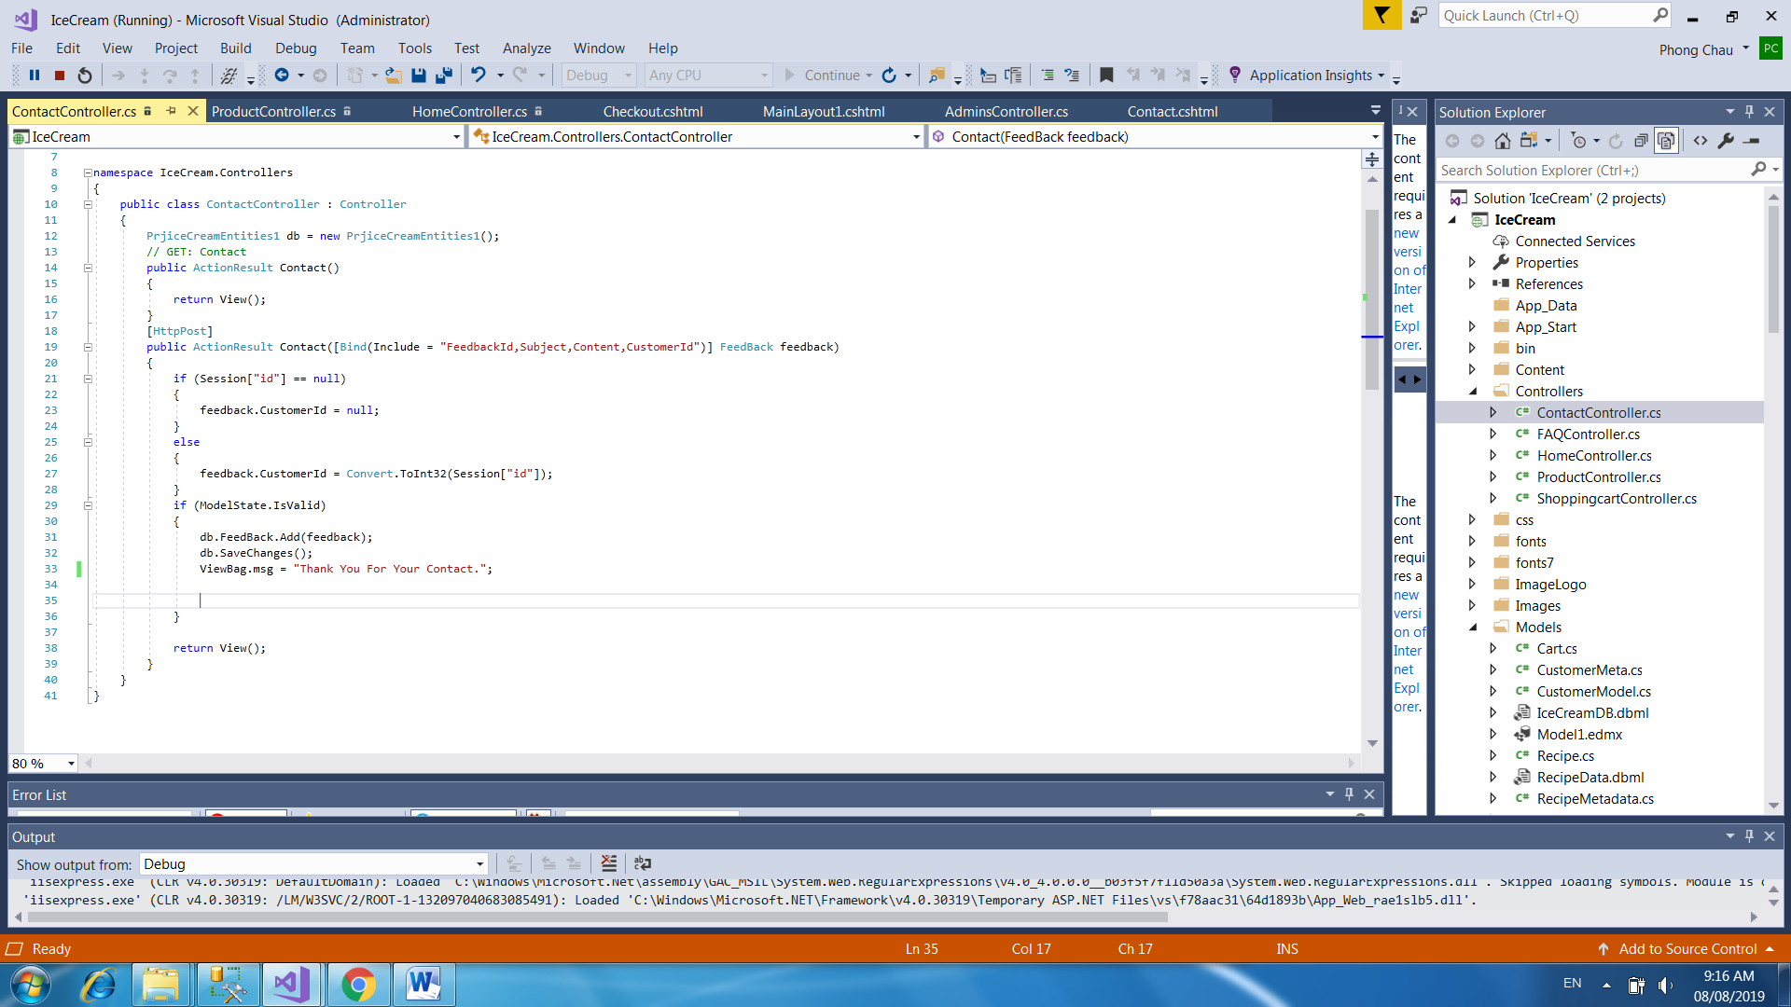

**View:**

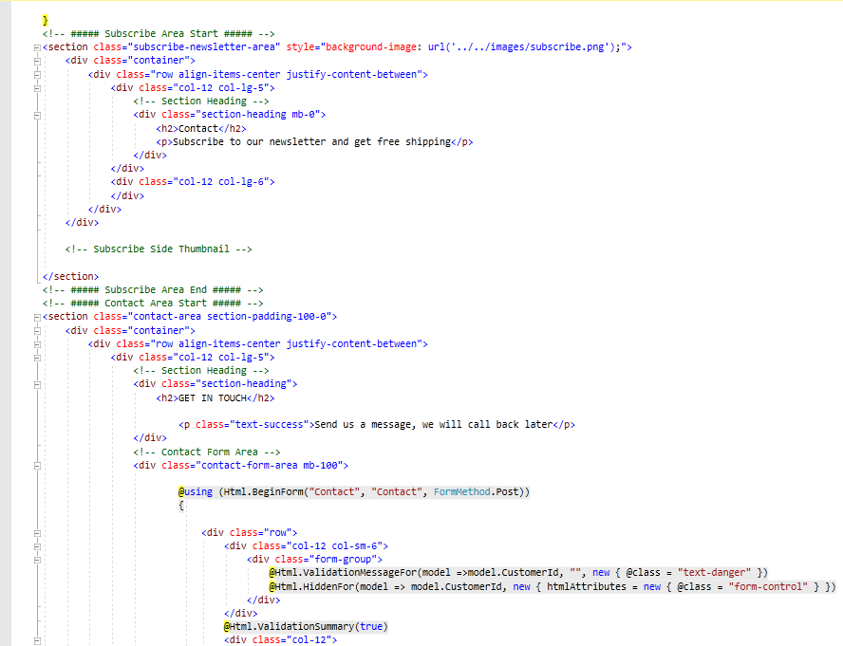

* 1. **Login Page:** Login form for user

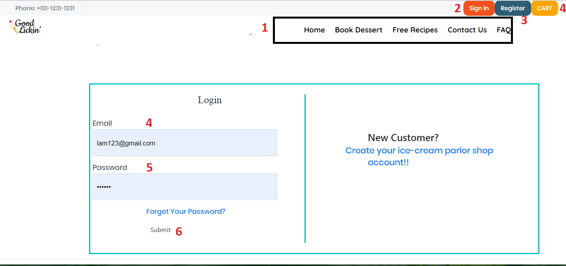

|  |  |  |  |  |  |  |
| --- | --- | --- | --- | --- | --- | --- |
| **No** | **Name** | **Type** | **Validation** | **Event** | **Description** | **Status** |
| 1 | Navigation Bar | Hyperlink |  | Click | Choose & click to go to sub pages | Enable |
| 2 | Login | Hyperlink |  | Click | Click to go to login page | Enable |
| 3 | Register | Hyperlink |  | Click | Click to go to register page | Enable |
| 4 | Cart | Hyperlink |  | Click | Click to go to cart page (must be login first) | Enable |
| 5 | Email | Textbox | - Not null - Min lengh:5 - Max length:20 | Focus | Input Email | Enable |
| 6 | Password | Password | - Not null - Min lengh:6 - Max length:20 | Focus | Input password | Enable |
| 7 | Login | Button |  | Click | Click to login | Enable |

**Source code:**

**Controller:**

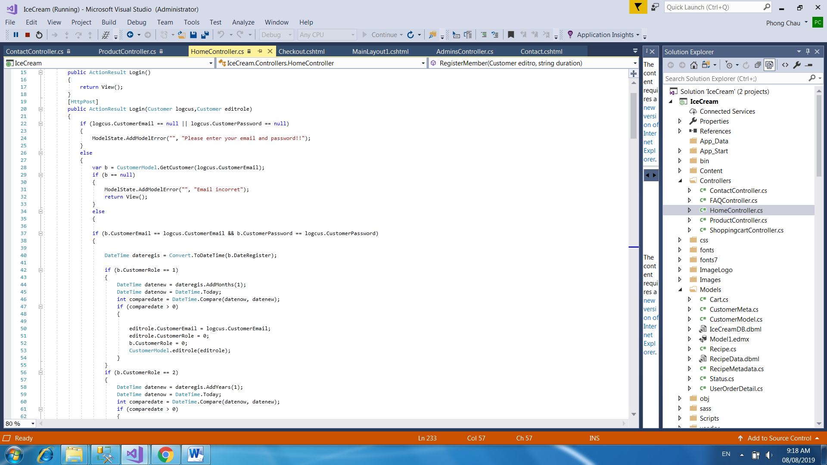

**View:**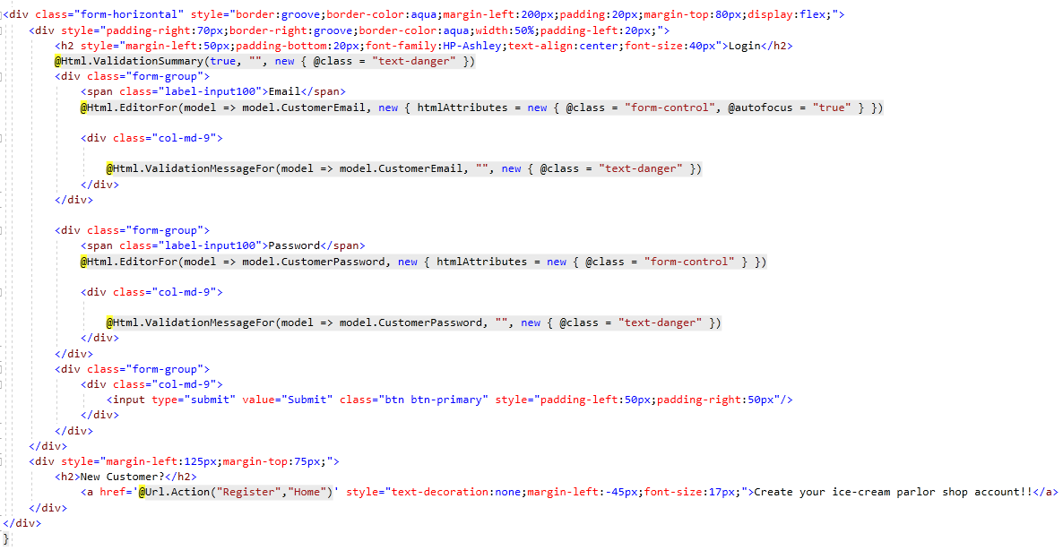

Figure 1

* 1. **Logout:** notification will appear when admin click logout button

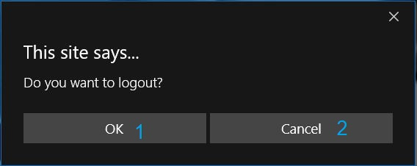

|  |  |  |  |  |  |  |
| --- | --- | --- | --- | --- | --- | --- |
| **No** | **Name** | **Type** | **Validation** | **Event** | **Description** | **Status** |
| 1 | btnOk | Button |  | Click | Click to logout | Enable |
| 2 | btnCancel | Button |  | Click | Click to return | Enable |

**Source code:**

**Controller:**

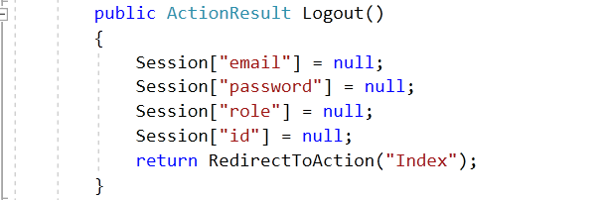

* 1. **Register Page:** Register form for user if they haven’t account.

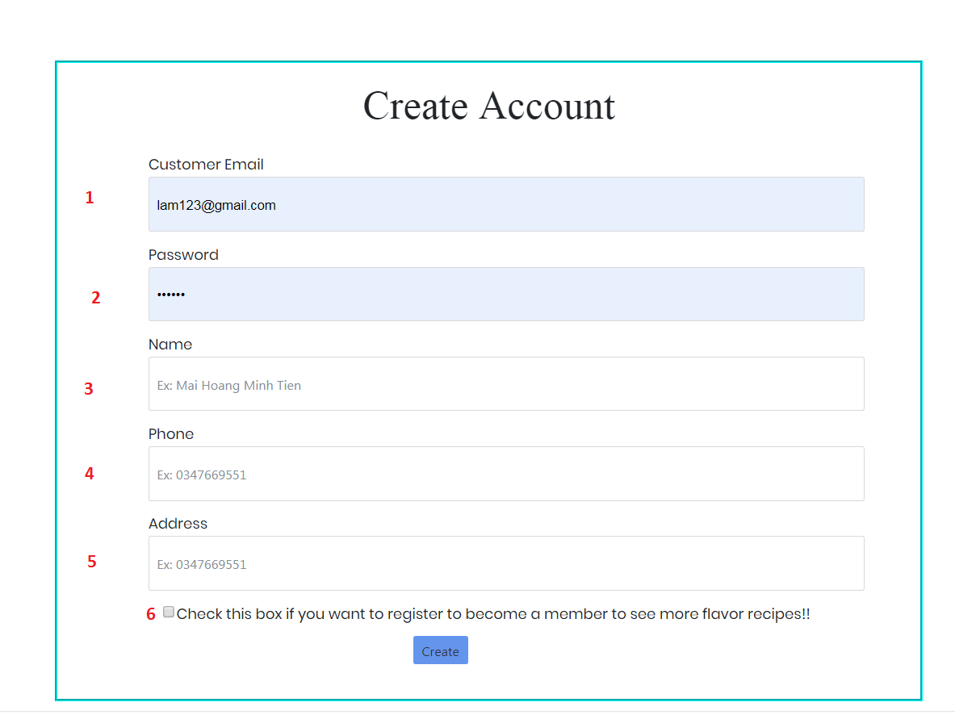

|  |  |  |  |  |  |  |
| --- | --- | --- | --- | --- | --- | --- |
| **No** | **Name** | **Type** | **Validation** | **Event** | **Description** | **Status** |
| 1 | CustomerEmail | Textbox | - Not null - Min lengh:5 - Max length:20 | Focus | Show your Email | Enable |
| 2 | Password | Password | - Not null - Min lengh:6 - Max length:20 | Focus | Input password | Enable |
| 3 | Name | Textbox | - Not null - Max length:50 | Focus | Input name | Enable |
| 4 | Phone Number | Textbox | - Not null - Max length:15 | Focus | Input phone number | Enable |
| 5 | Address | Textbox | - Not null - Max length:50 | Focus | Input address | Enable |
| 6 | CheckBox | Radio |  | Focus | Check value member if user want | Enable |

**Source code:**

**Controller:**

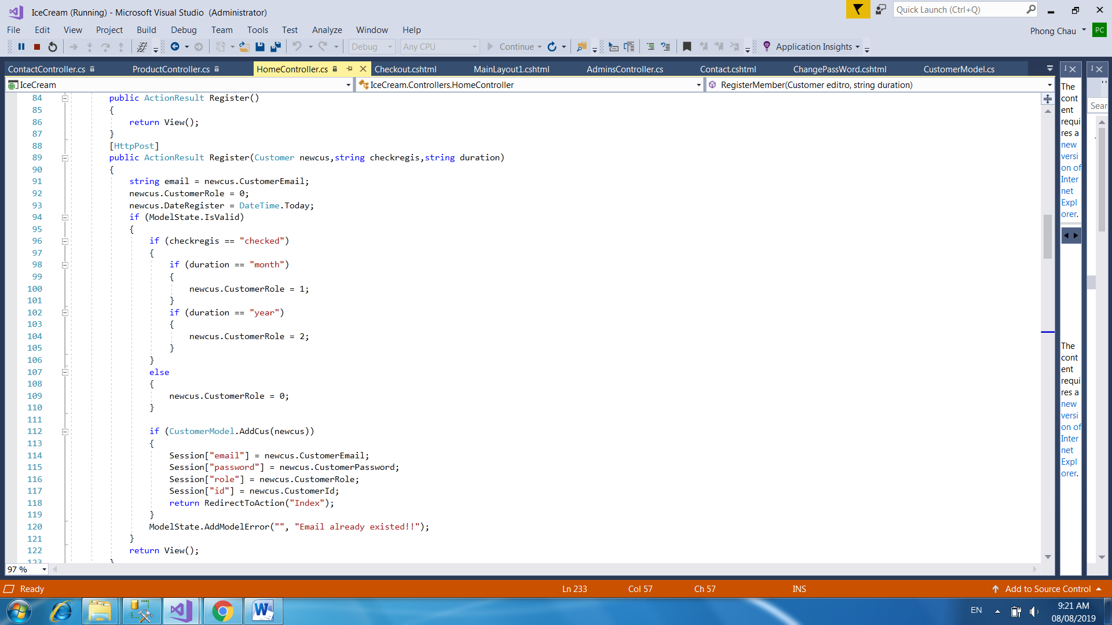

**View:**

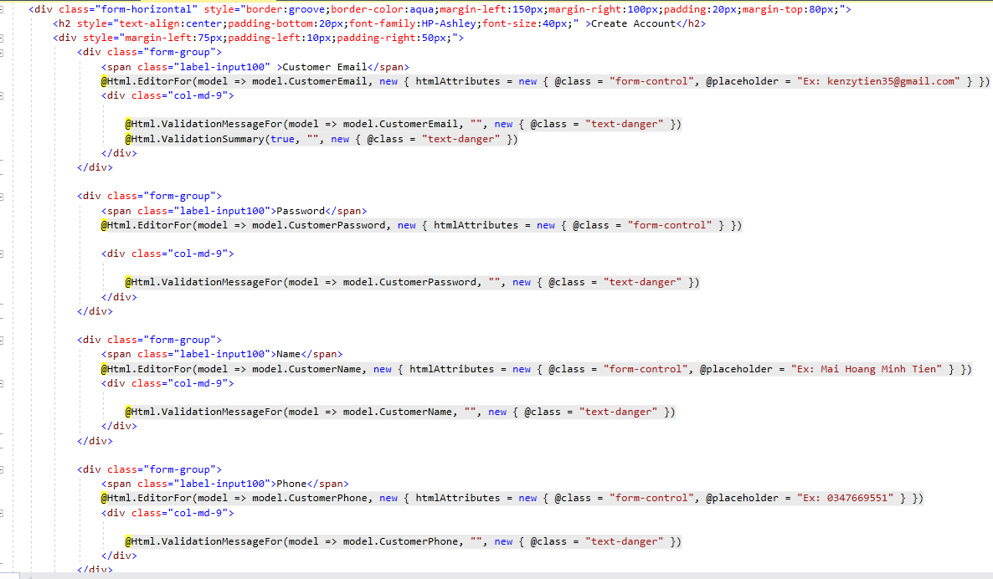

* 1. **Change Personal Information Page:** User can change their information here.

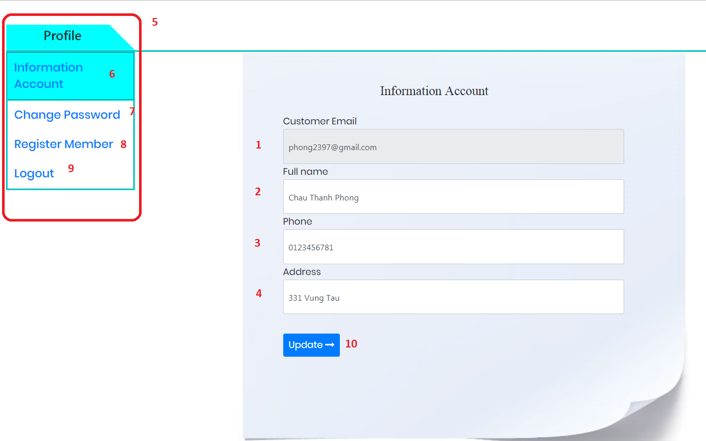

|  |  |  |  |  |  |  |
| --- | --- | --- | --- | --- | --- | --- |
| **No** | **Name** | **Type** | **Validation** | **Event** | **Description** | **Status** |
| 1 | Customer Email | Textbox (Read only) |  | Focus | Email | Disable |
| 2 | Full name | Textbox | - Not null - Max length:50 | Focus | Input to change full name | Enable |
| 3 | Phone Number | Textbox | - Not null - Max length:15 | Focus | Input to change phone number | Enable |
| 4 | Address | Textbox | - Not null - Max length:50 | Focus | Input to change address | Enable |
| 5 | Profile | Textbox |  | Focus | Tab to change page | Enable |
| 6 | Information Account | Hyperlink |  | Click | Go to Profile page(must be login) | Enable |
| 7 | Register Member | Hyperlink |  | Click | Go to Register page (must be login) | Enable |
| 8 | Change Password | Hyperlink |  | Click | Go to Change Password Page | Enable |
| 9 | Logout | Hyperlink |  | Click | Sign out the page | Enable |
| 10 | Update | Button |  | Click | Click to update information | Enable |

**Source code:**

**Controller:**

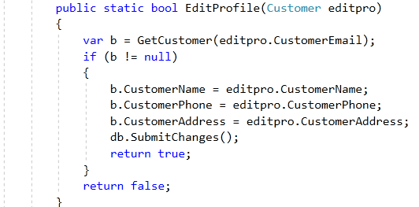

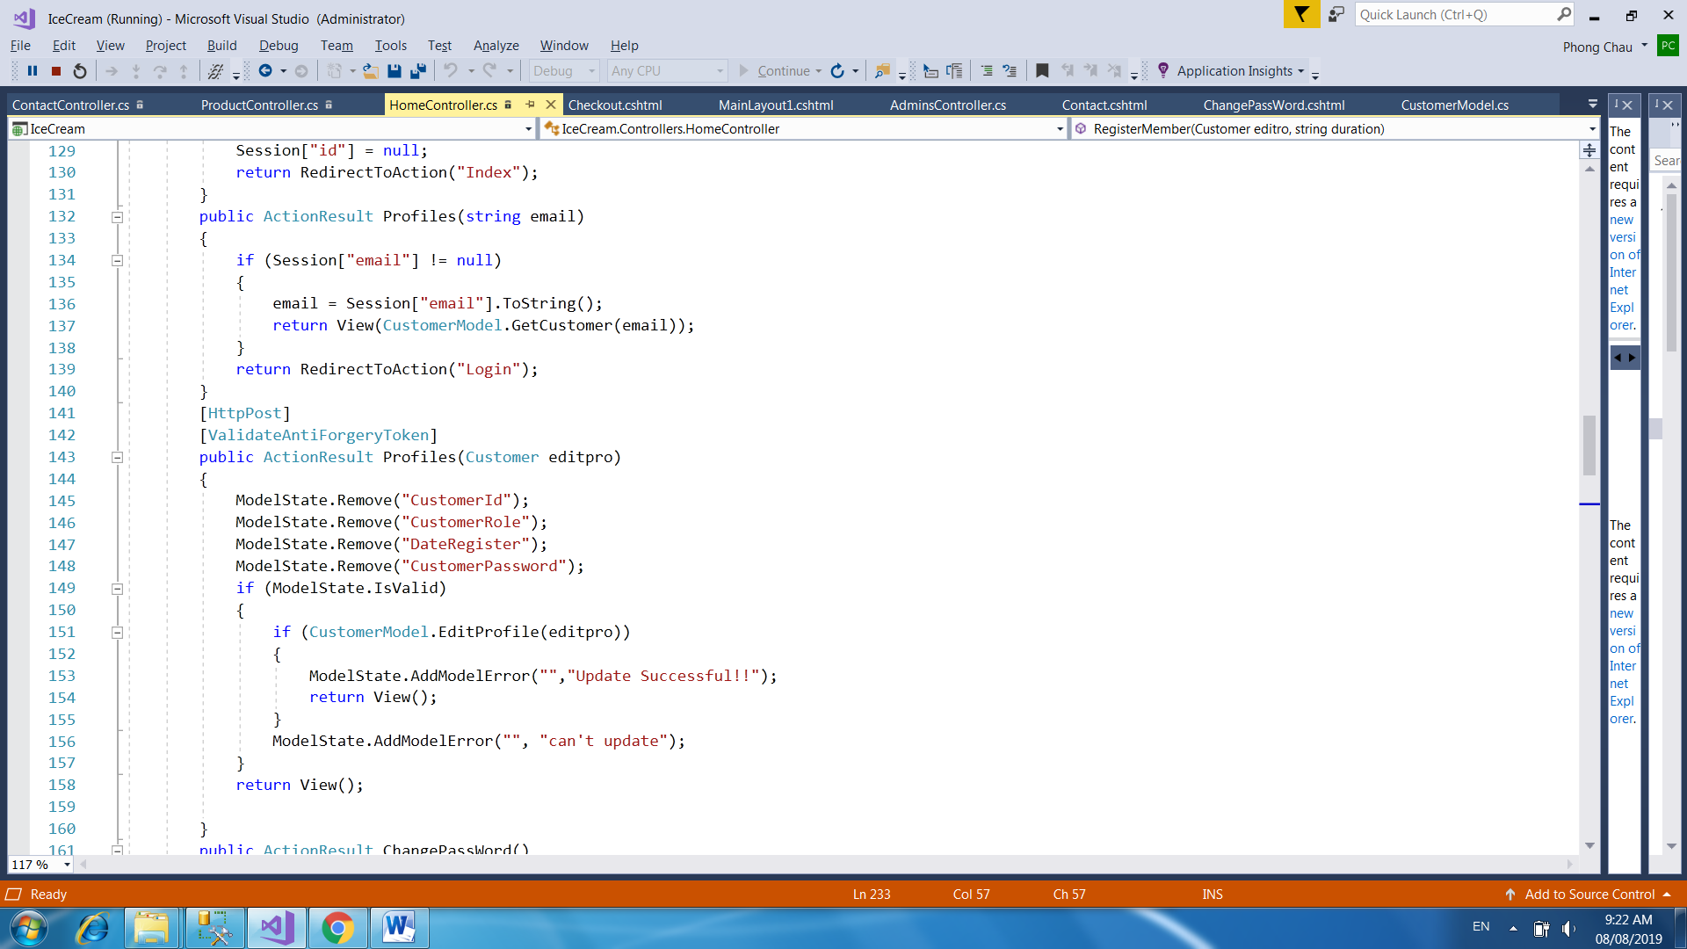

**View:**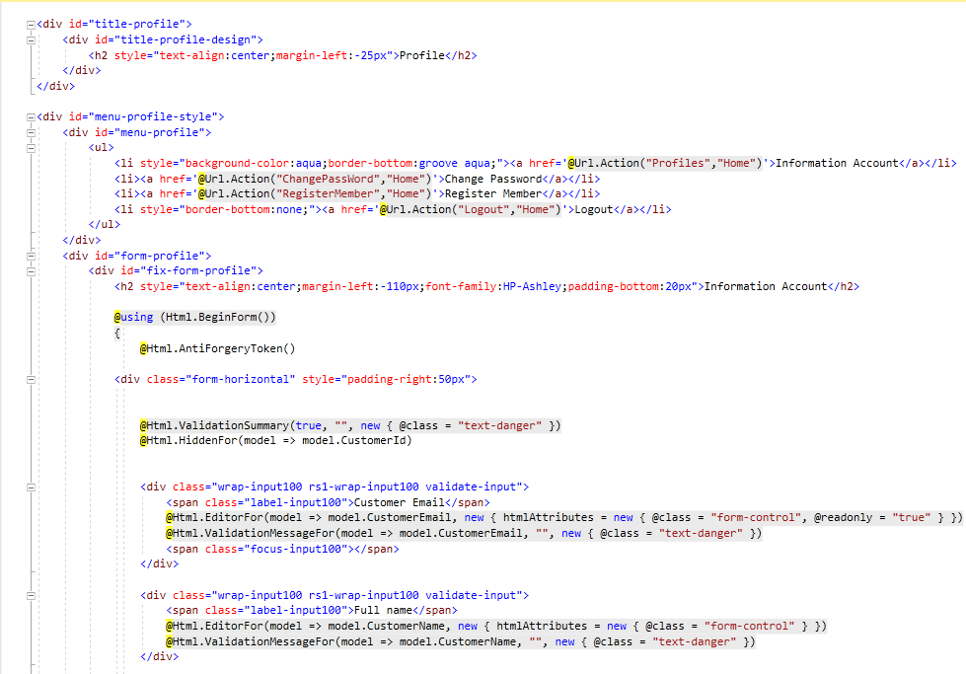

* 1. **Update Password Page:** User can change their Password here.

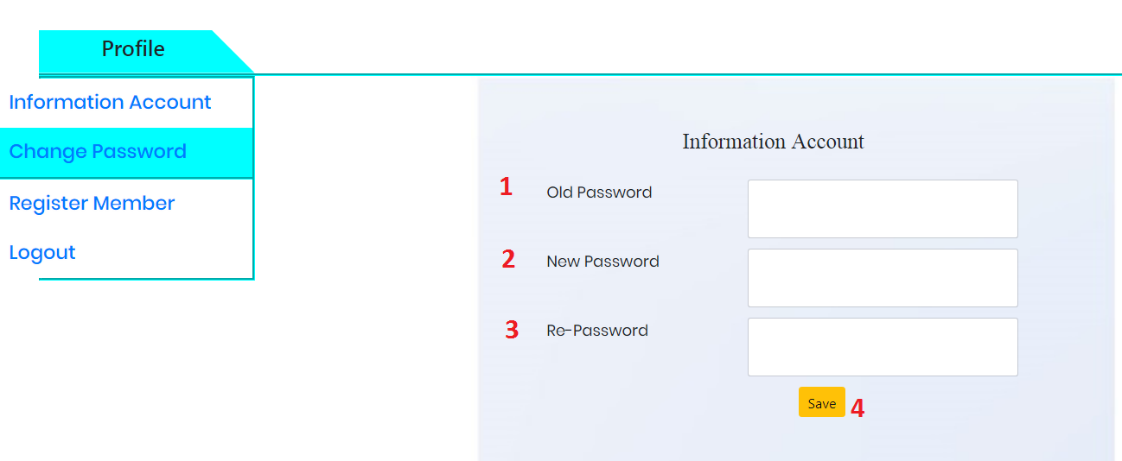

|  |  |  |  |  |  |  |
| --- | --- | --- | --- | --- | --- | --- |
| **No** | **Name** | **Type** | **Validation** | **Event** | **Description** | **Status** |
| 1 | Old Password | Old Password | - Not null - Min lengh:6 - Max length:20 | Focus | Input the old password | Enable |
| 2 | New Password | New Password | - Not null - Min lengh:6 - Max length:20 | Focus | Input the new password | Enable |
|  | RePassword | Re Password | Not null - Max length:50 | Focus | reinput the new password | Enable |
| 3 | Save | Button | - | Click | Click to update information | Enable |

**Source code:**

**Controller:**

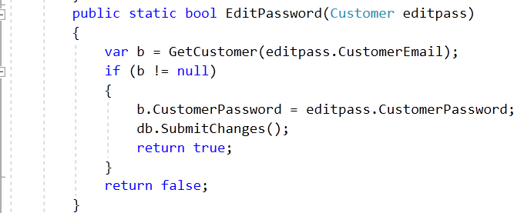

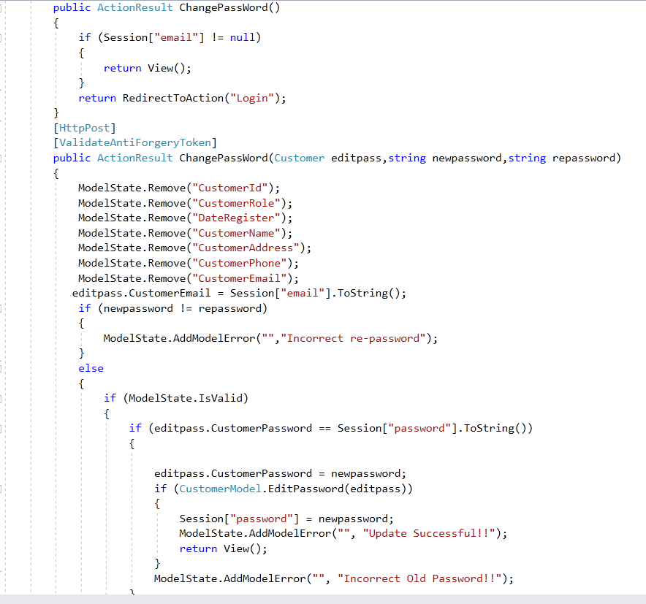

**View:**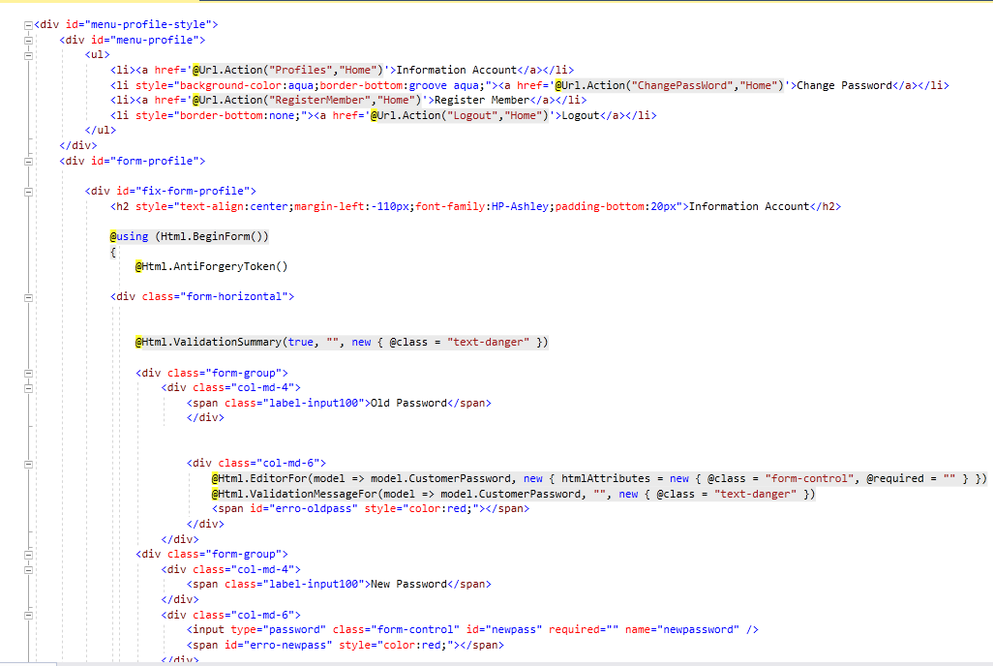

* 1. **Register Member Page:**If the user is not register ,user can fill value member is this profiles.

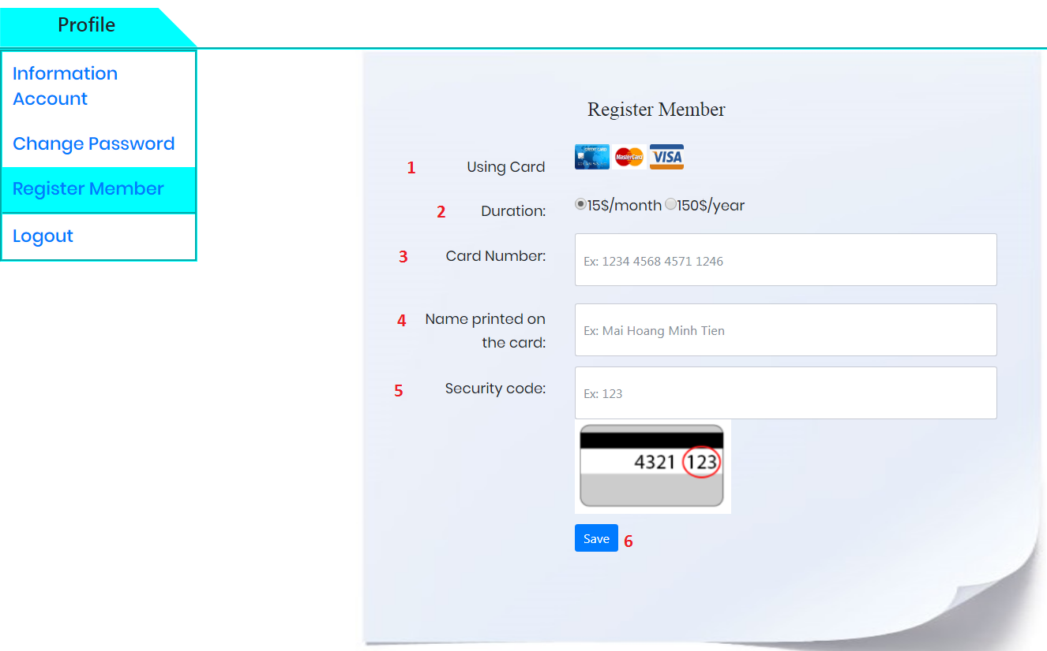

|  |  |  |  |  |  |  |  |
| --- | --- | --- | --- | --- | --- | --- | --- |
| **No** | **Name** | **Type** | **Validation** | | **Event** | **Description** | **Status** |
| 1 | Using Card | img | |  | Focus |  | Enable |
| 2 | Duration | Radio Btn | |  | Focus | Choose member price | Enable |
| 3 | Name Printed on the card | Textbox | |  | Focus | Input Full Name | Enable |
| 4 | Name Printed on the card | TextBox | |  | Focus | Input Name On Card | Enable |
| 5 | Security Code | Textbox | |  | Focus | Input the number | Enable |

**Source code:**

**Controller:**

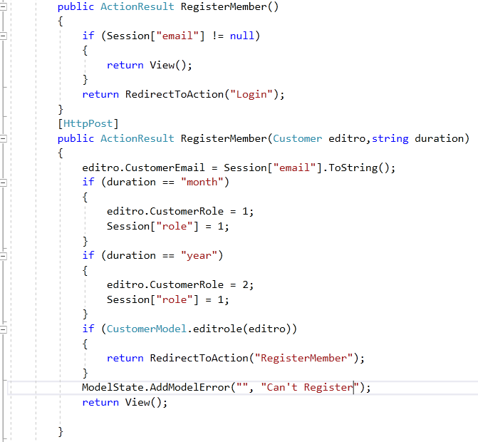

**View:**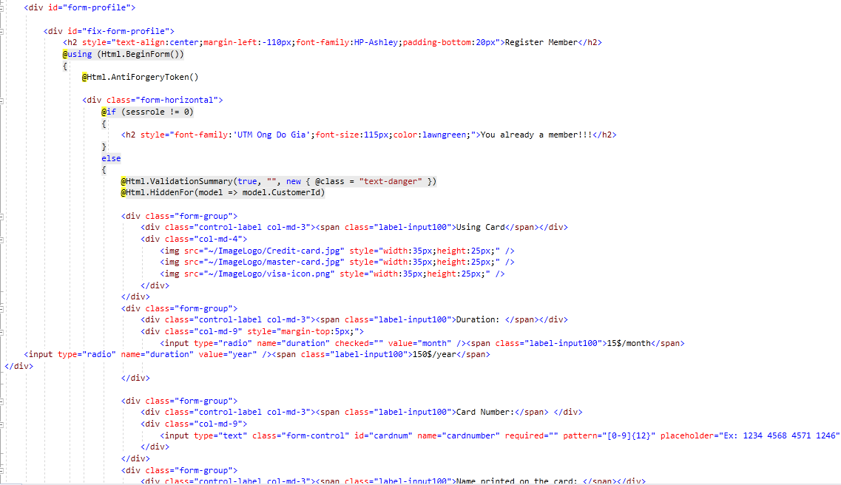

* 1. **Book Page:** This page display list of medicines, user can search item with search bar.

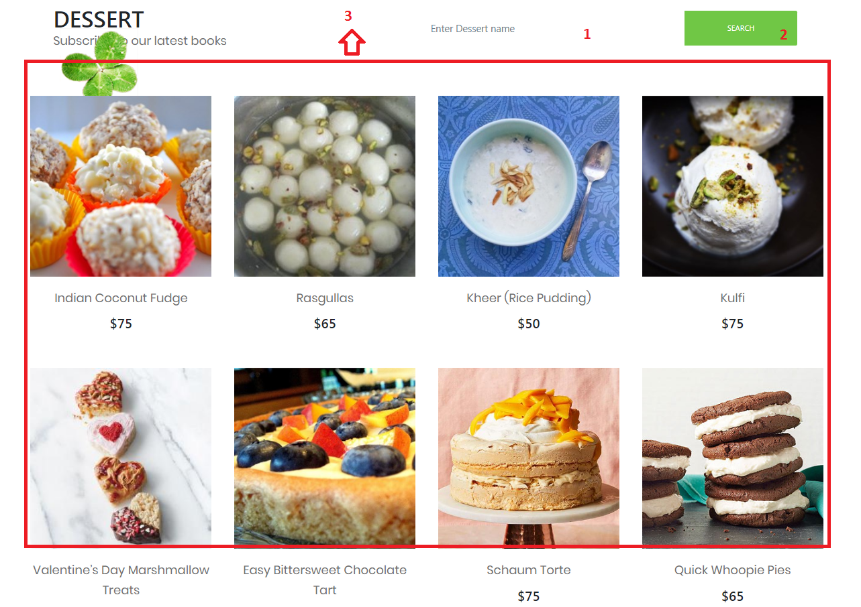

|  |  |  |  |  |  |  |
| --- | --- | --- | --- | --- | --- | --- |
| **No** | **Name** | **Type** | **Validation** | **Event** | **Description** | **Status** |
| 1 | txtSearch | Textbox |  | Focus | Input medicine name to search | Enable |
| 2 | btnSearch | Button |  | Click | Click to search Book | Enable |
| 3 | btnAdd to Cart | Button |  | Click | Click to search medicine | Enable |

**Source code:**

**Controller:**

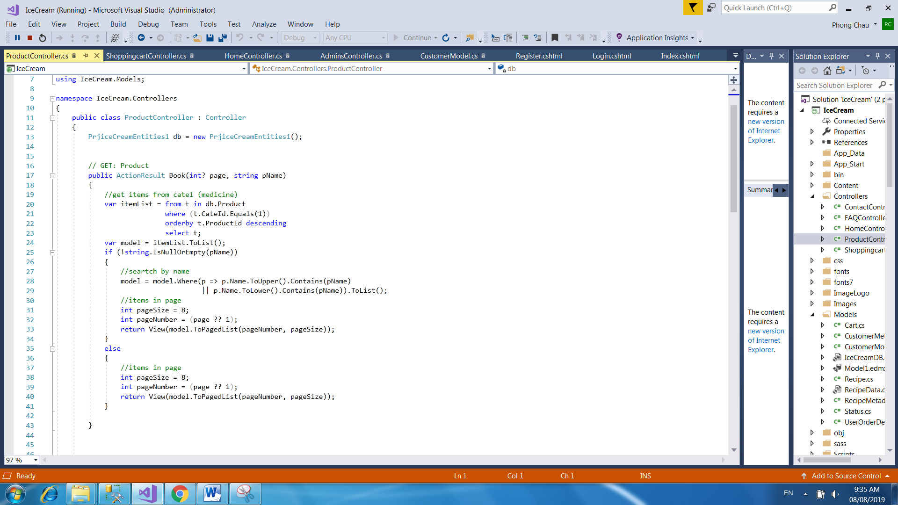

**View:**

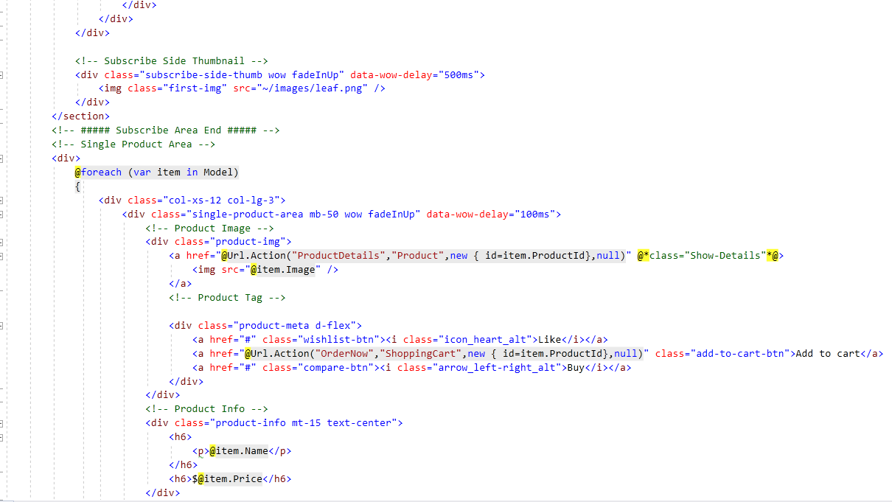

* 1. **Product Details Page:** This page display information of a product. User

also can add this product to cart

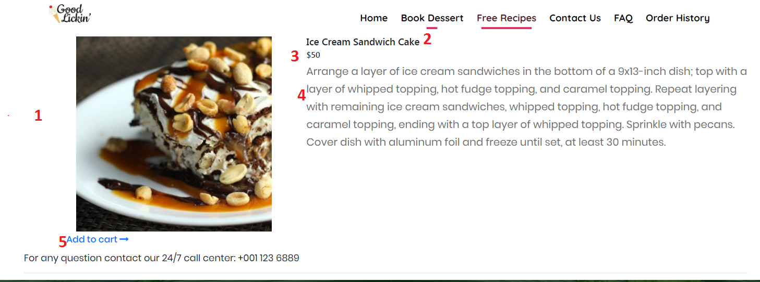

|  |  |  |  |  |  |  |
| --- | --- | --- | --- | --- | --- | --- |
| **No** | **Name** | **Type** | **Validation** | **Event** | **Description** | **Status** |
| 1 | Image | Image |  |  | Product’s image | Enable |
| 2 | Name | Textbox (Read only) |  |  | Product’s name | Enable |
| 3 | Price | Textbox (Read only) |  |  | Product’s price | Enable |
| 4 | Description | Textbox (Read only) |  |  | Product’s description | Enable |
| 5 | Add to Cart | Button |  | Click | Click to add product to your cart (must be login first) | Enable |

**Source code:**

**Controller:**

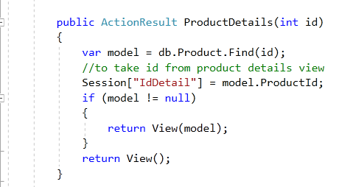

**View:**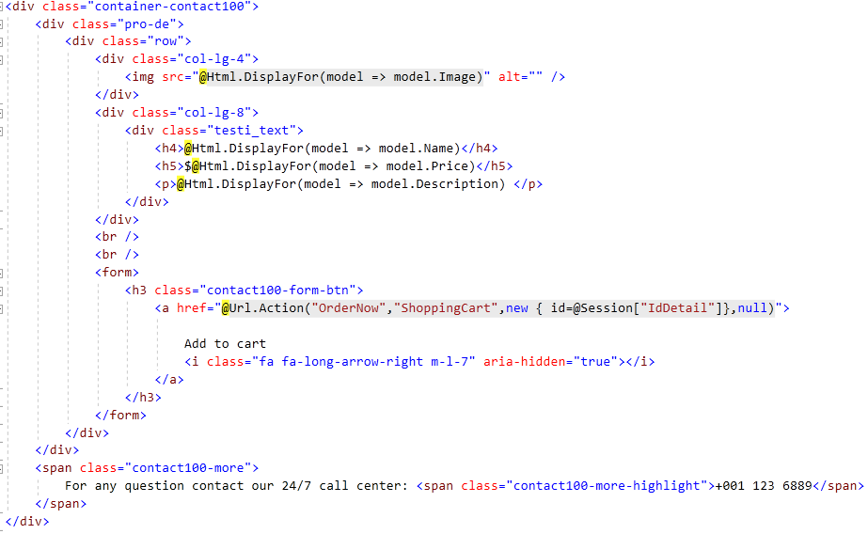

* 1. **Free Recipes:** This page display list of recipes for your user don’t use account.

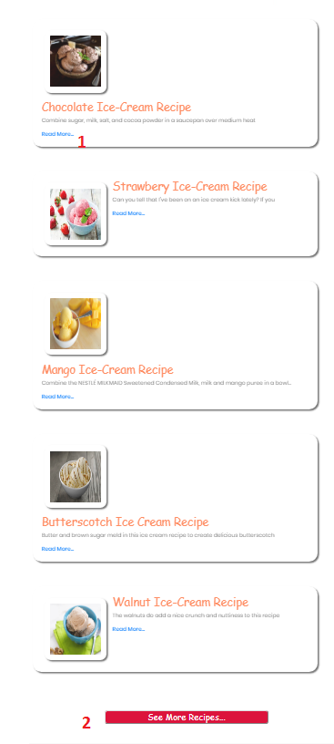

|  |  |  |  |  |  |  |
| --- | --- | --- | --- | --- | --- | --- |
| **No** | **Name** | **Type** | **Validation** | **Event** | **Description** | **Status** |
| 1 | Read | Button |  | Click | Go to the video detail of recipes | Enable |
| 2 | See More Recipe | Button |  | Click | Click to Full Recipes(must be login) | Enable |

**Source code:**

**Controller:**

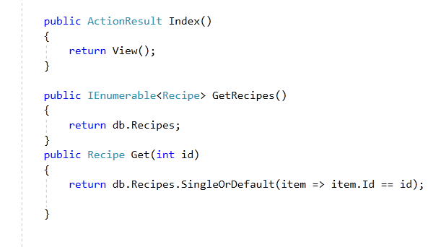

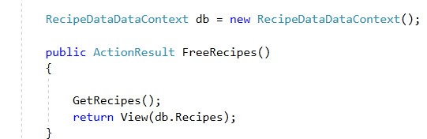

**View:**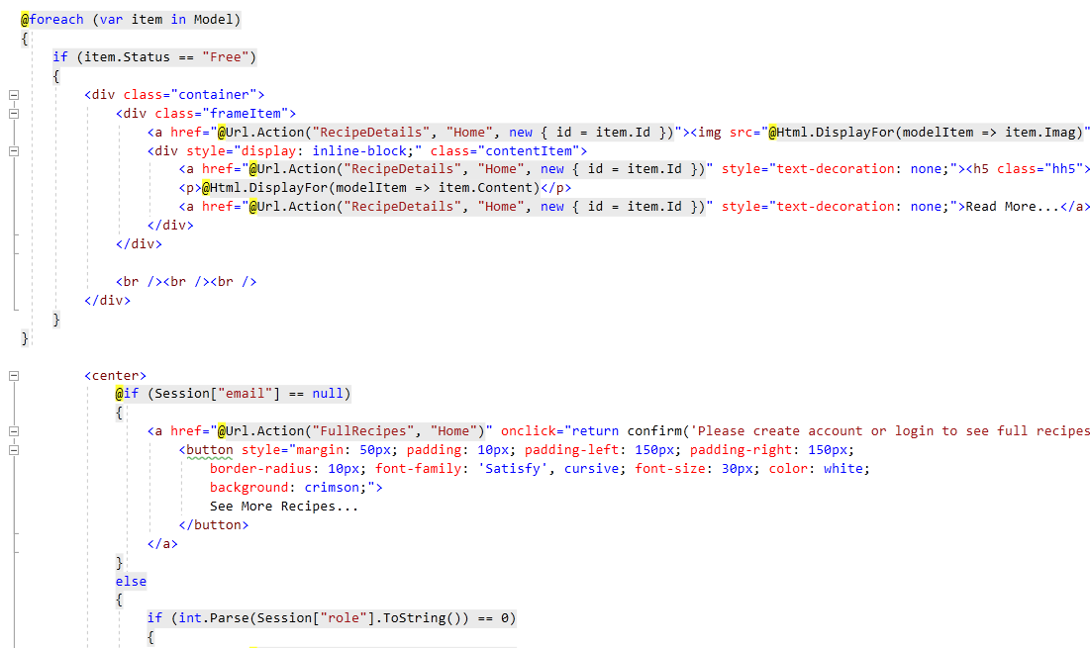

* 1. **Full Recipes:** This page display list of recipes for your user register a member as month or year

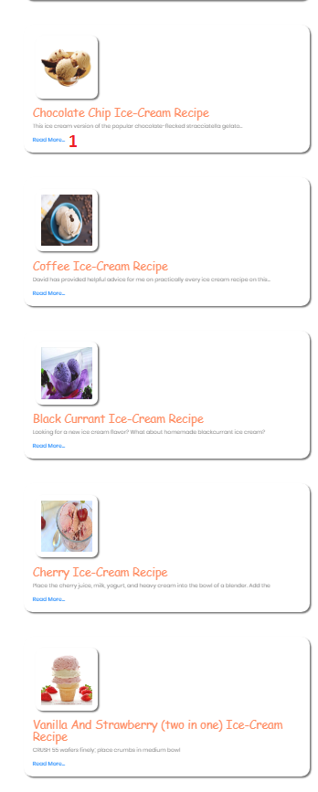

|  |  |  |  |  |  |  |
| --- | --- | --- | --- | --- | --- | --- |
| **No** | **Name** | **Type** | **Validation** | **Event** | **Description** | **Status** |
| 1 | Read | Button |  | Click | Go to the video detail of recipes | Enable |

**Source code:**

**Controller:**

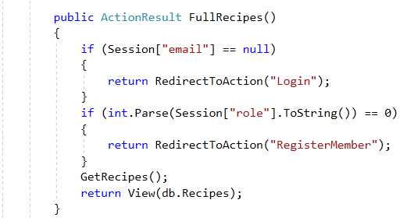

**View:**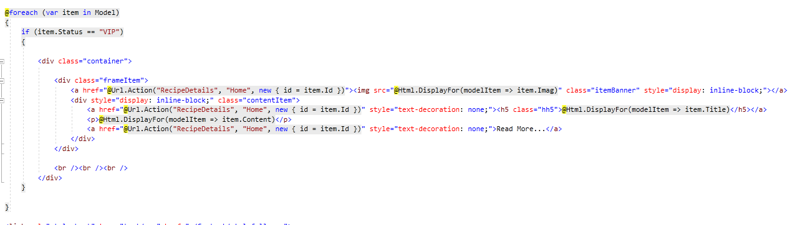

* 1. **Detail of Recipes:** This page display the way to cook this favourite ice cream.

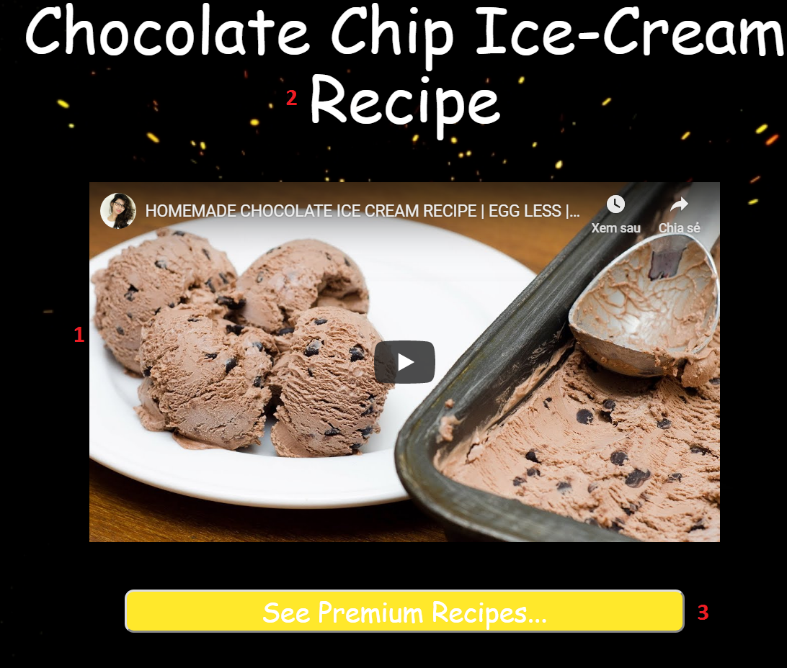

|  |  |  |  |  |  |  |
| --- | --- | --- | --- | --- | --- | --- |
| **No** | **Name** | **Type** | **Validation** | **Event** | **Description** | **Status** |
| 1 | Video | Linkyt |  |  | Product’s Video | Enable |
| 2 | Name | Textbox (Read only) |  |  | Recipes’s name | Enable |
| 3 | btnRecipes | Button | Login before see full recipes |  | Click go to the full recipes page (must be login first) | Enable |

**Source code:**

**Controller:**

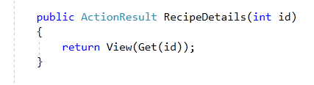

**View:**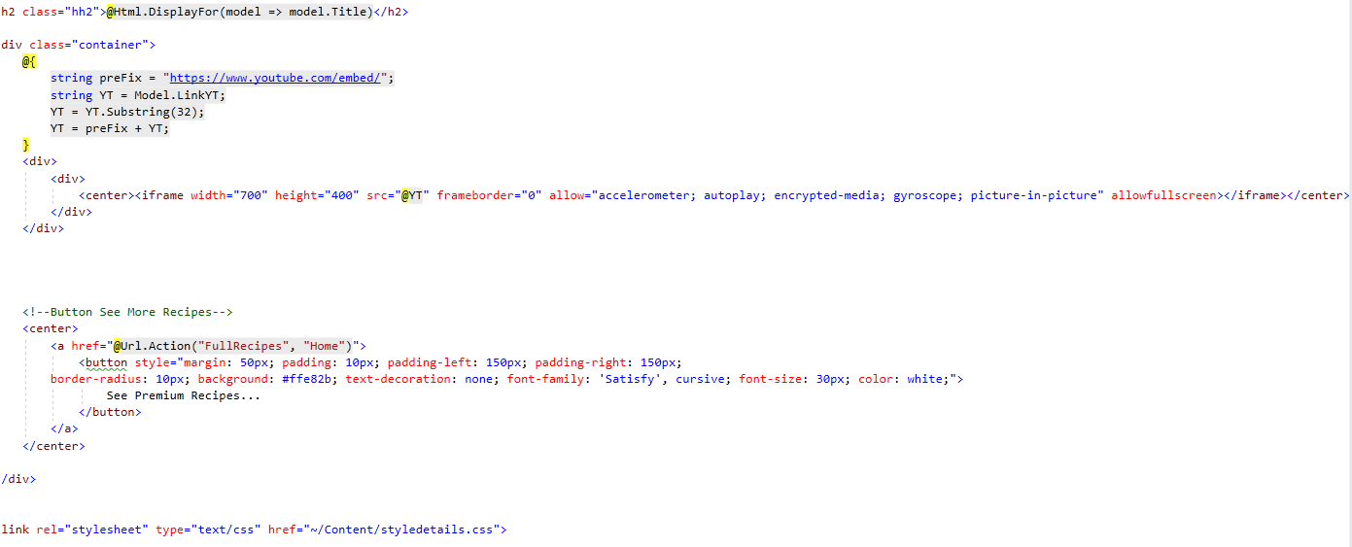

* 1. **FAQ Page:** This page display list of frequently of question.

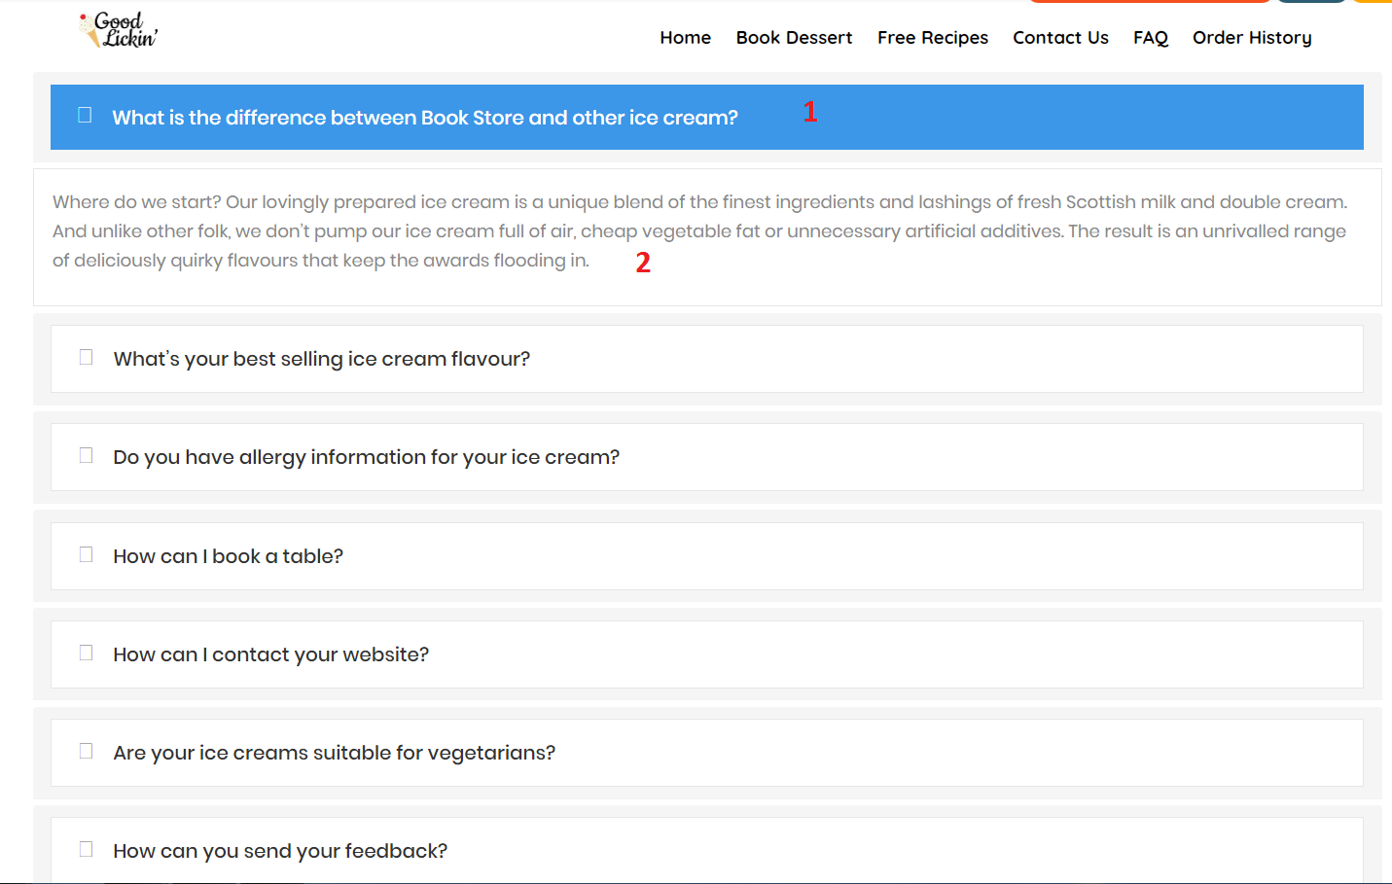

|  |  |  |  |  |  |  |
| --- | --- | --- | --- | --- | --- | --- |
| **No** | **Name** | **Type** | **Validation** | **Event** | **Description** | **Status** |
| 1 | PanelTitle | Textbox |  | Focus | Question’s Customer | Enable |
| 2 | PanelBody | Textbox |  | Focus | Anser from my website | Enable |

**Source code:**

**View:**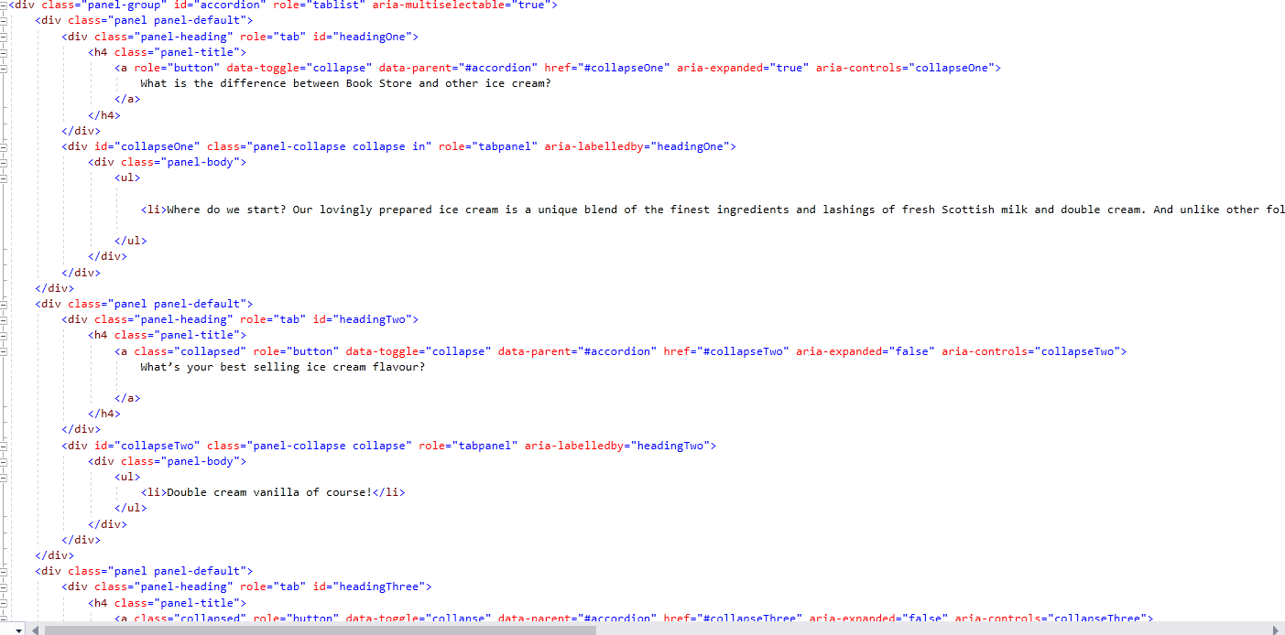

* 1. **Your Cart Page:** Items which user had chosen will display here.

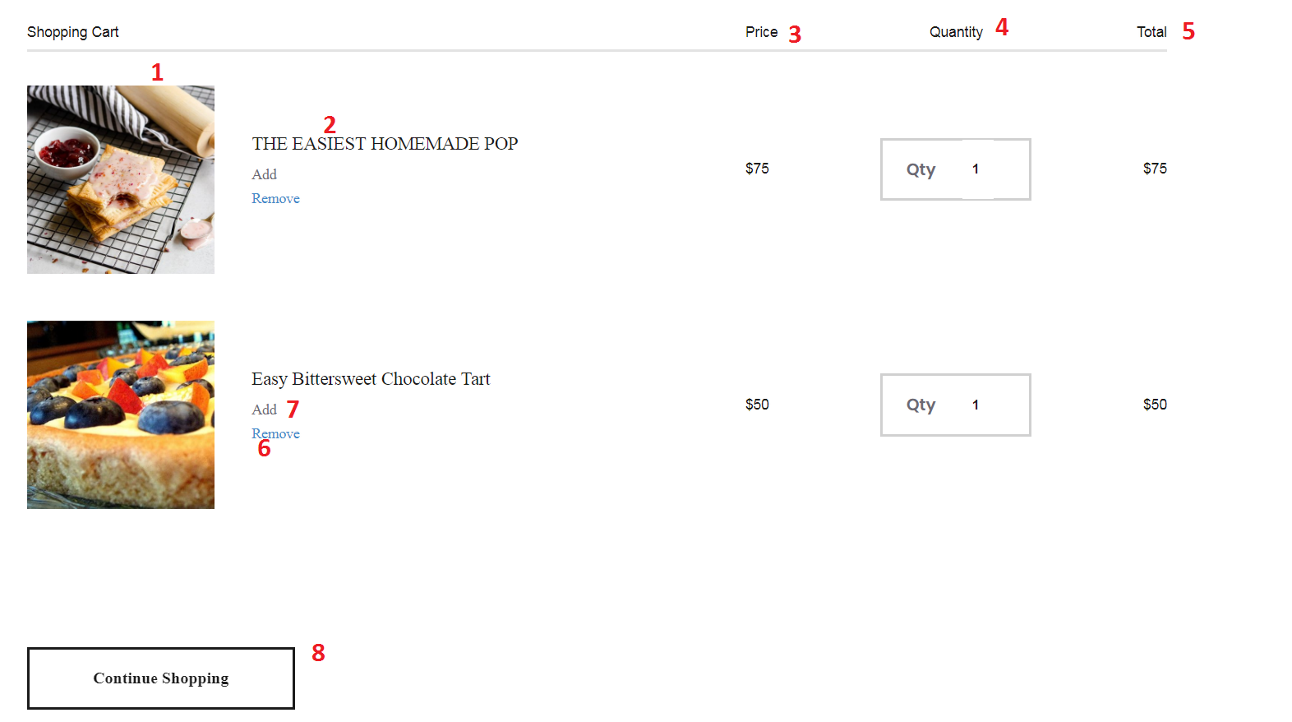

|  |  |  |  |  |  |  |
| --- | --- | --- | --- | --- | --- | --- |
| **No** | **Name** | **Type** | **Validation** | **Event** | **Description** | **Status** |
| 1 | Image | Image |  |  | Product’s image | Enable |
| 2 | Name | Textbox (Read only) |  |  | Product’s name | Enable |
| 3 | Price | Textbox (Read only) |  |  | Product’s unit price | Enable |
| 4 | Quantity | Textbox |  | Focus | Product’s quantity, if user want update quantity, type number of product want to buy and then press enter, the cart will reload & update | Enable |
| 5 | Subtotal | Textbox (Read only) |  |  | Product’s subtotal price | Enable |
| 6 | Remove | Button |  | Click | Click to clear cart | Enable |
| 7 | Add | Button |  | Click | Click to update quantity | Enable |
| 8 | Continue shopping | Button |  | Click | Click to go back home page | Enable |

**Source code:**

**Controller:**

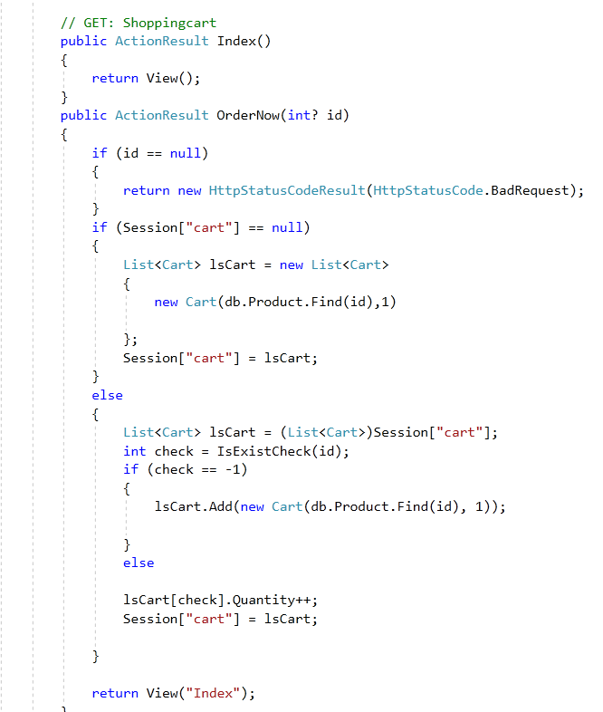

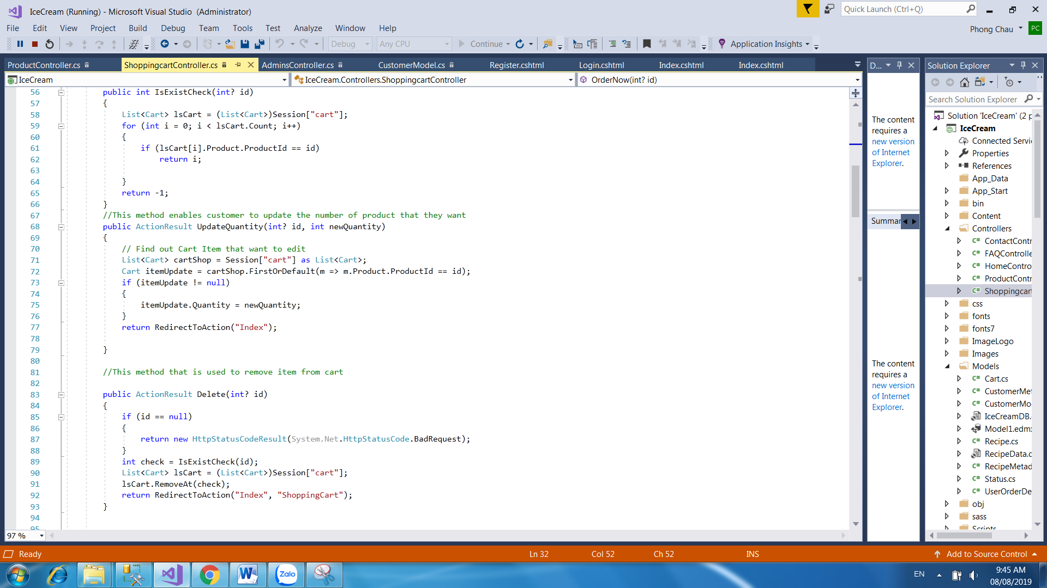

**View:**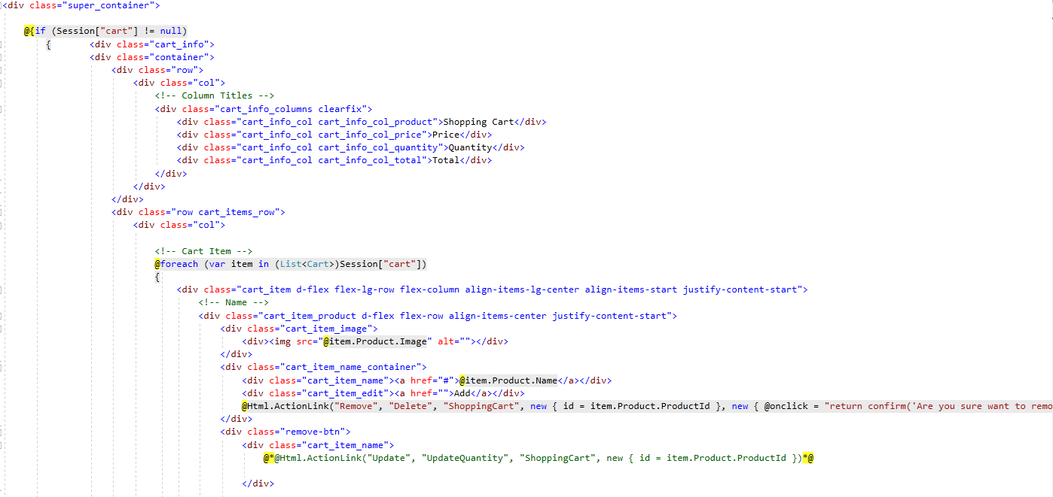

* 1. **Checkout page:** This page show for user confirm payment.

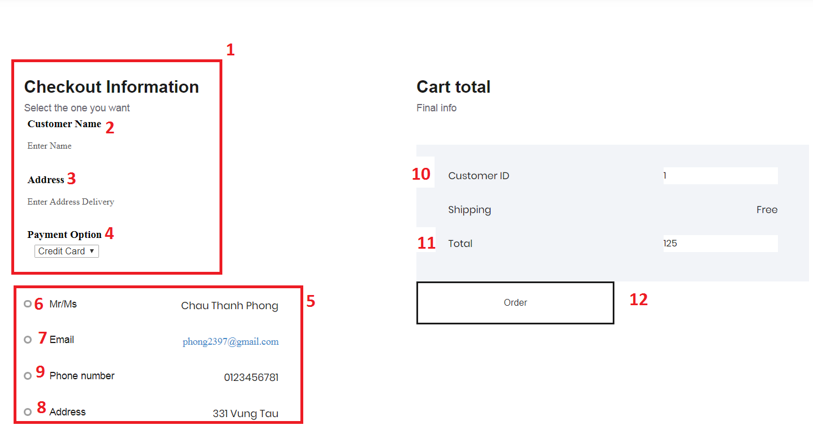

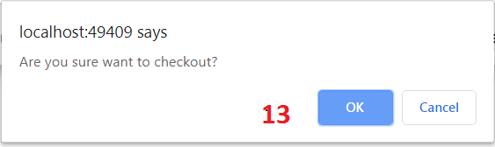

|  |  |  |  |  |  |  |
| --- | --- | --- | --- | --- | --- | --- |
| **No** | **Name** | **Type** | **Validation** | **Event** | **Description** | **Status** |
| 1 | User’Order | Textbox |  |  | Form Order | Enable |
| 2 | Customer name | Textbox | Not null  Max length :30 |  | User input into the name  (both user register and no register) | Enable |
| 3 | Address | Textbox | Not null  Max length :30 |  | User input into the Address  (both user register and no register) | Enable |
| 4 | Payment option | Select | Not null |  | User choose your payment to order(both user register and no register) | Enable |
| 5 | Inforamtion user | Textbox (Read only) |  |  | User’s information(must be login) | Enable |
| 6 | User Name | Textbox (Read only) |  |  | User’s Name | Enable |
| 7 | Email | Textbox (Read only) |  |  | User’s Email | Enable |
| 8 | Address | Textbox (Read only) |  |  | User’s Address | Enable |
| 9 | Phone Number | Textbox (Read only) |  |  | User’s Phone | Enable |
| 10 | CustomerID | TextBox(Read only) |  | Focus | Primary key of Customer | Enable |
| 11 | Total | TextBox(read only) |  | Focus | Sum of quantity and price of product | Enable |
| 12 | Order | Button |  | Click | Click to checkout order | Enable |
| 13 | Ok | Button |  | Click | Click to confirm checkout | Enable |

**Source code:**

**Controller:**

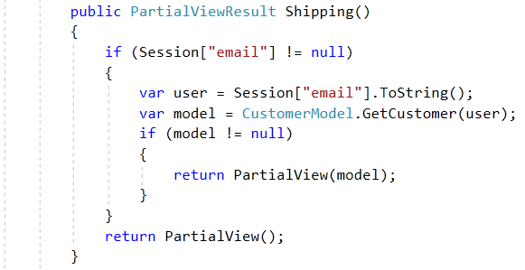

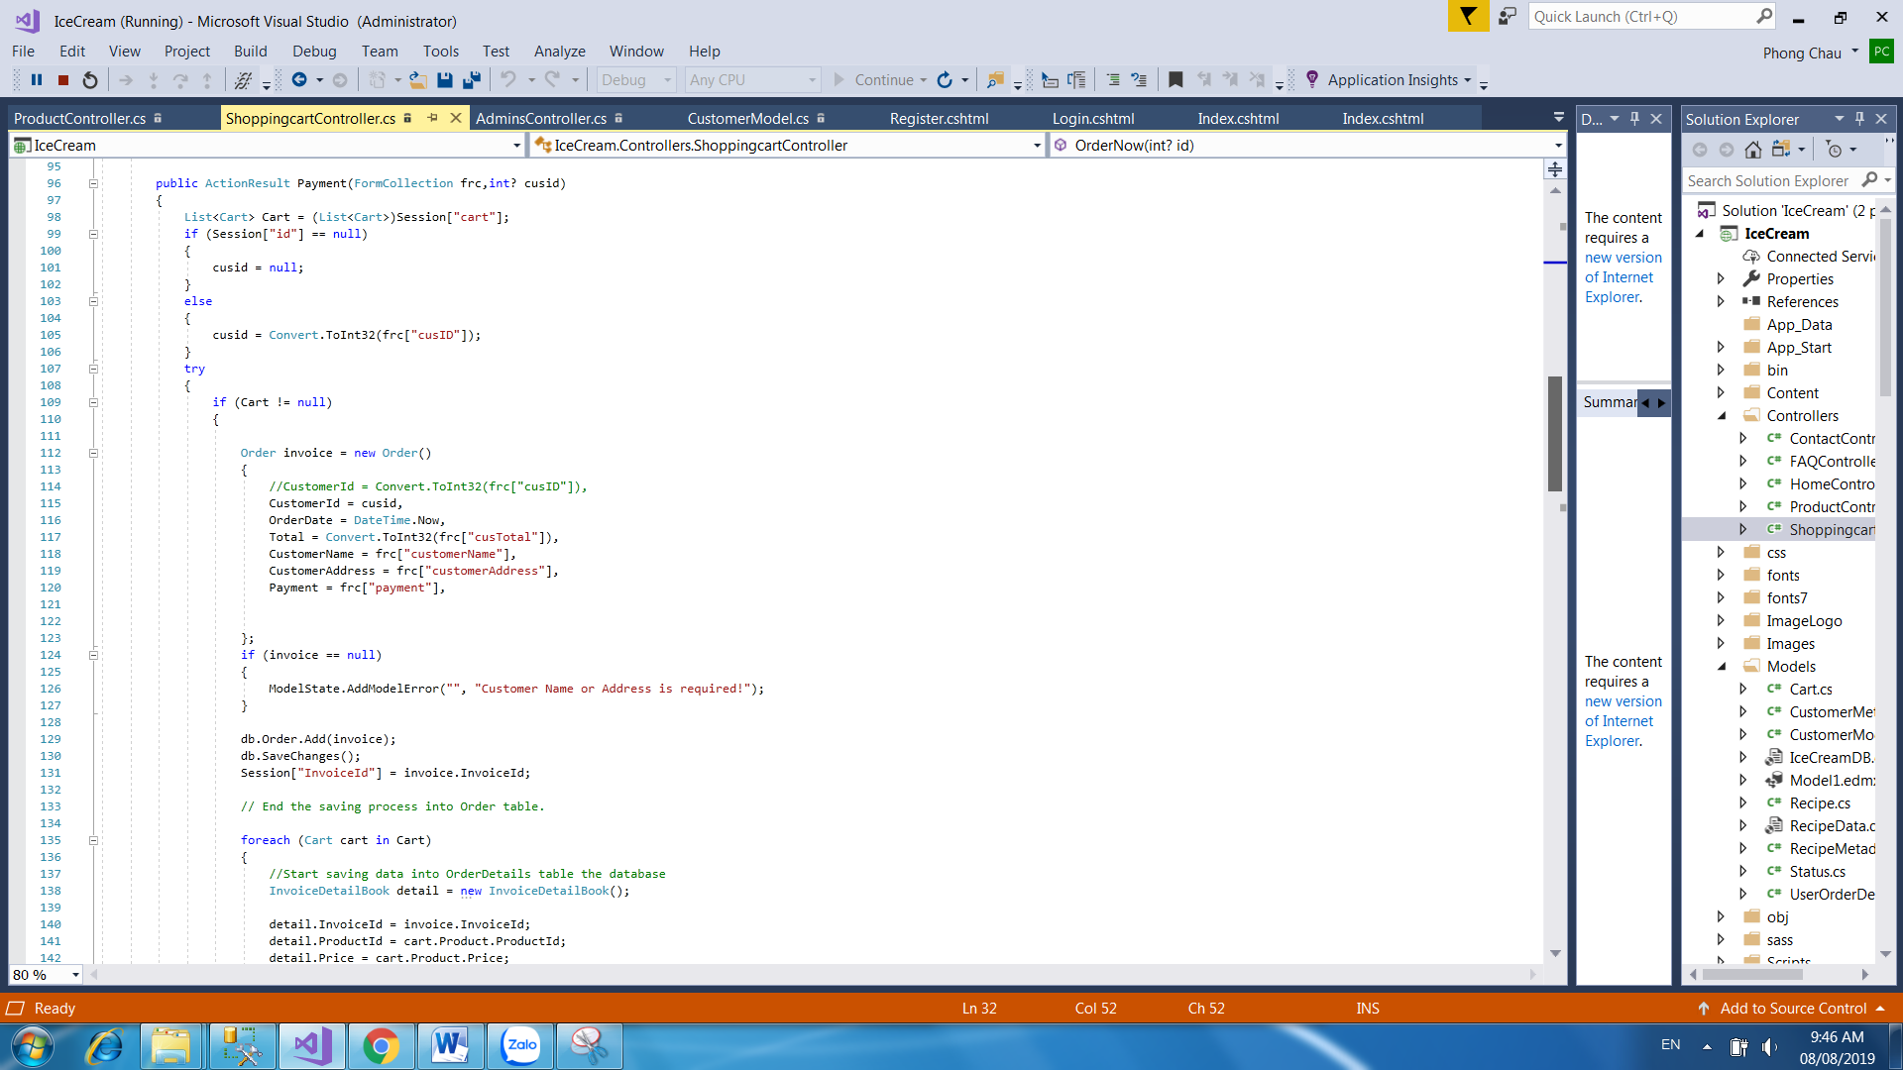

**View:**

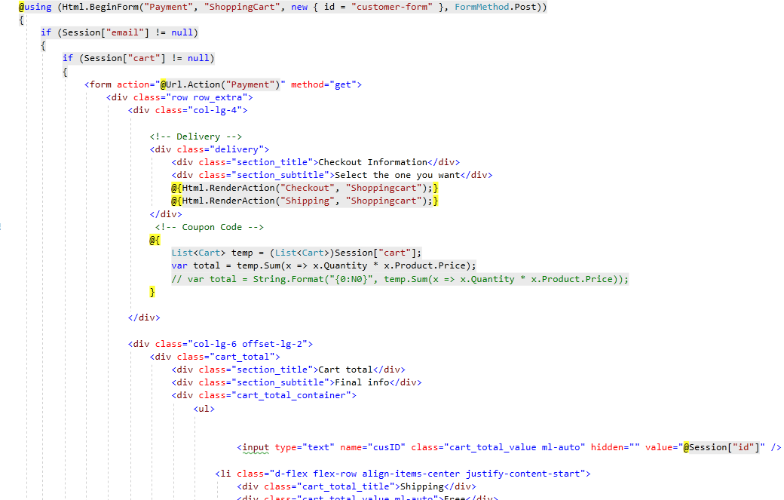

* 1. **InvoiceDetailBook:** this page display information about order user just bought

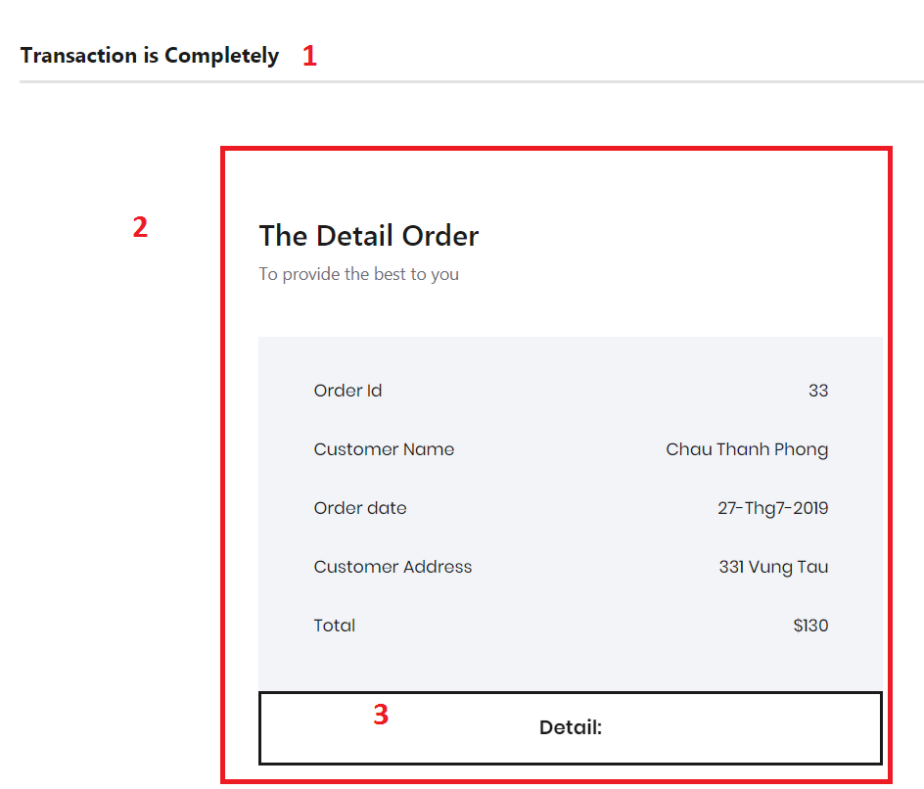

|  |  |  |  |  |  |  |
| --- | --- | --- | --- | --- | --- | --- |
| **No** | **Name** | **Type** | **Validation** | **Event** | **Description** | **Status** |
| 1 | Result | Textbox (Read only) |  |  | Message to customer order complete | Enable |
| 2 | Order information | Textbox (Read only) |  |  | Order information | Enable |
| 3 | Details | Button |  |  | Click to view details of this order | Enable |

**Source code:**

**Controller:**

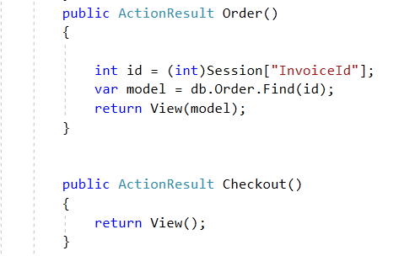

**View:**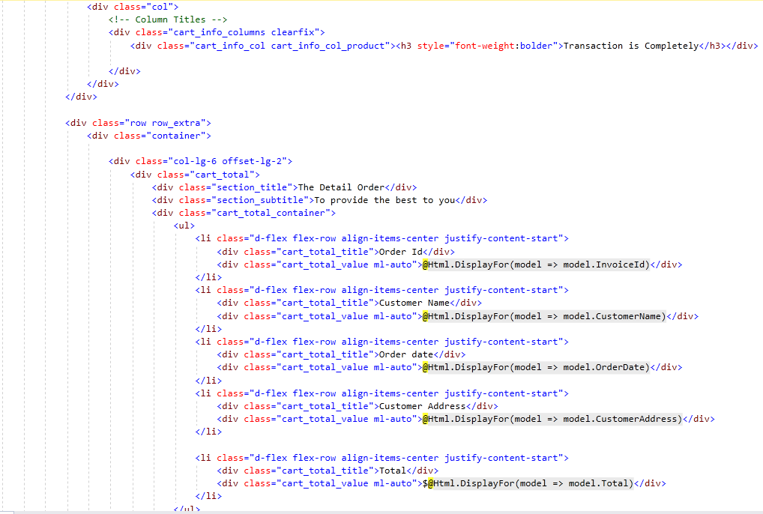

* 1. **Details of an order:** when user click details button in order details page, it will show details of it.

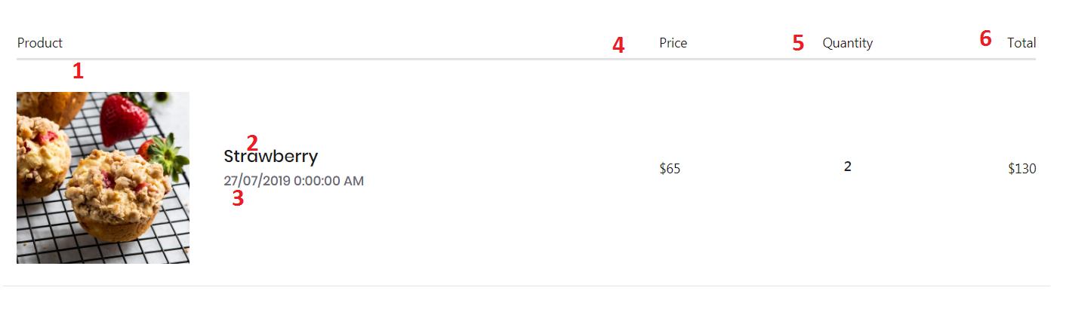

|  |  |  |  |  |  |  |
| --- | --- | --- | --- | --- | --- | --- |
| **No** | **Name** | **Type** | **Validation** | **Event** | **Description** | **Status** |
| 1 | Image | Textbox (Read only) |  |  | Product’s image | Enable |
| 2 | Product Name | Textbox (Read only) |  |  | Product’s name | Enable |
| 3 | Order Date | Textbox (Read only) |  |  | Order date | Enable |
| 4 | Unit price | Textbox (Read only) |  |  | Product’s unit price | Enable |
| 5 | Quantity | Textbox (Read only) |  |  | Quantity | Enable |
| 6 | Subtotal | Textbox (Read only) |  |  | Product’s subtotal | Enable |

**Source code:**

**Controller:**

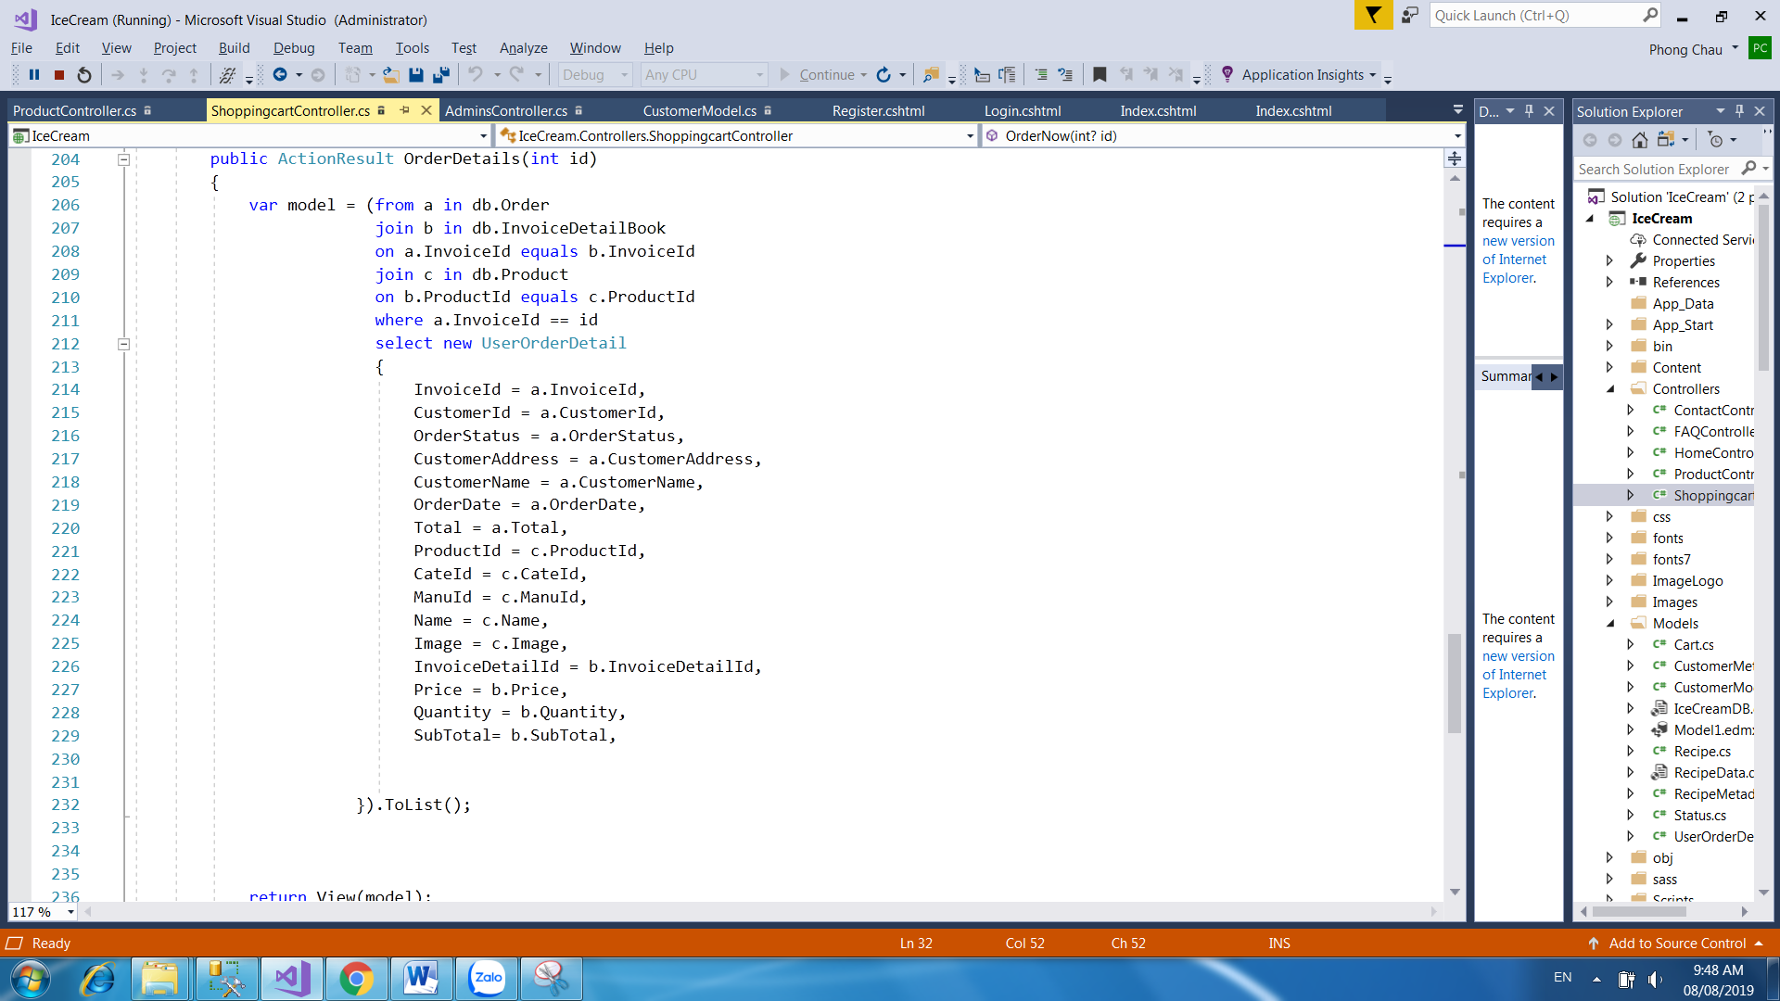

**View:**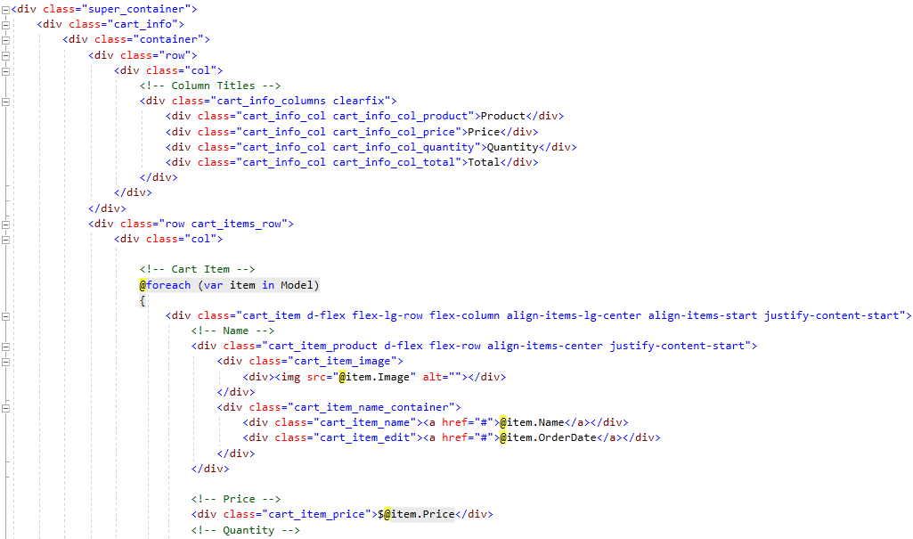

* 1. **Personal order history:** this page display history all orders of personal user. User can view it by click to menu “Order History” appears when user login successfully.



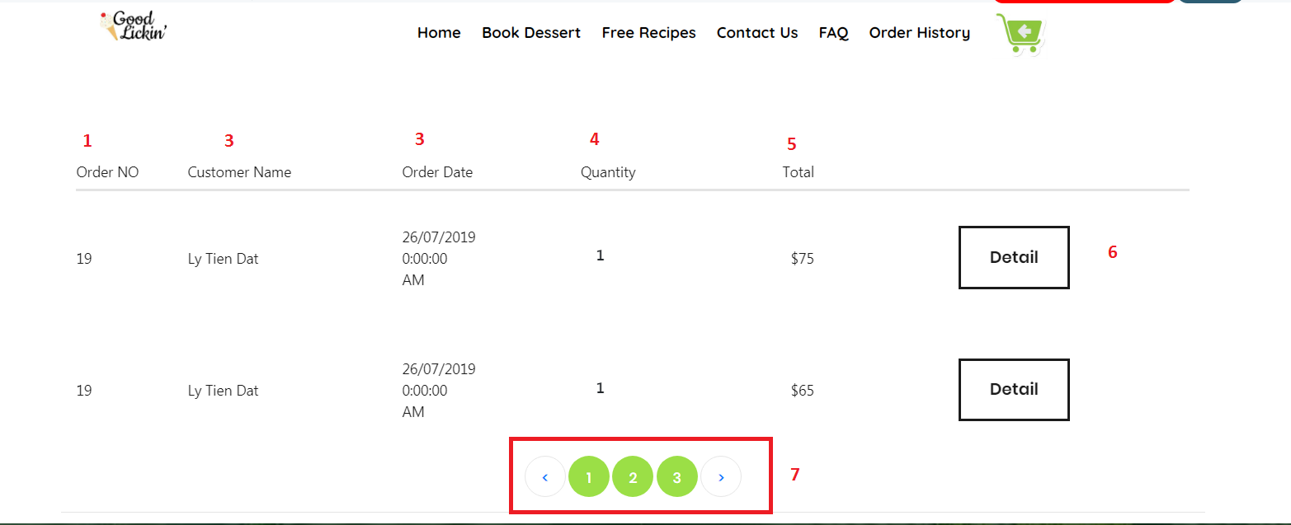

|  |  |  |  |  |  |  |
| --- | --- | --- | --- | --- | --- | --- |
| **No** | **Name** | **Type** | **Validation** | **Event** | **Description** | **Status** |
| 1 | OrderId | Textbox (Read only) |  |  | Id of Order | Enable |
| 2 | Customer Name | Textbox (Read only) |  |  | Customer’s Name | Enable |
| 3 | Order Date | Textbox (Read only) |  |  | Order date | Enable |
| 4 | Quantity | Textbox (Read only) |  |  | Quantity | Enable |
| 5 | Subtotal | Textbox (Read only) |  |  | Product’s subtotal | Enable |
| 6 | btnDetail | Button |  | Click | Details of Order | Enable |
| 7 | Number Page | Hyperlink |  | Click | Number Page Order history |  |

**Source code:**

**Controller:**

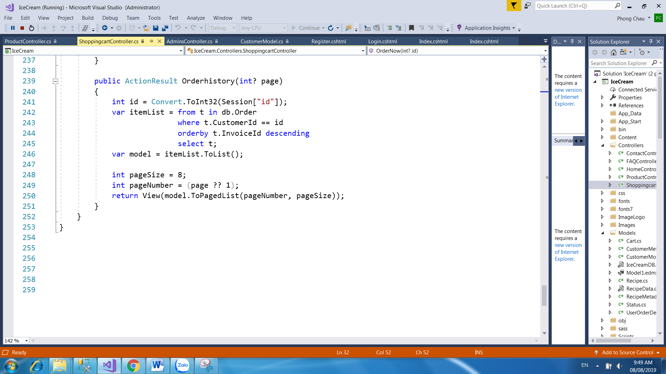

**View:**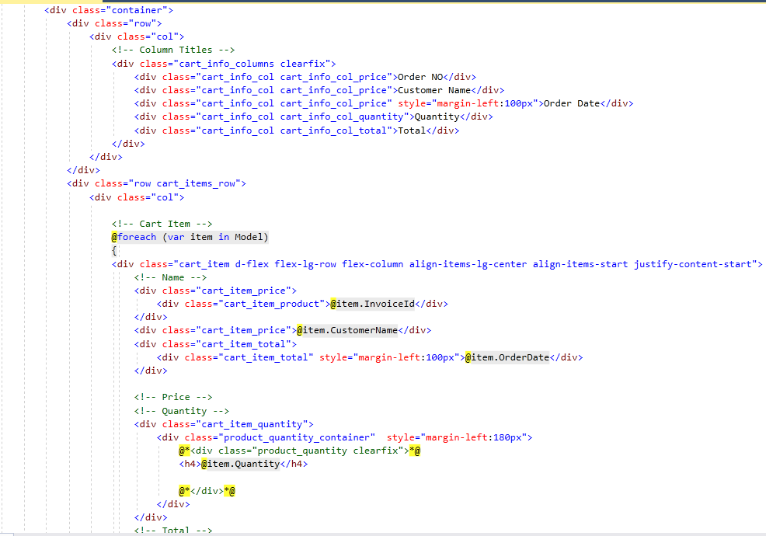

1. **Admin Interface:**
   1. **Login Page**: Login form for admin (default: Username: **admin**, password: **123456**)

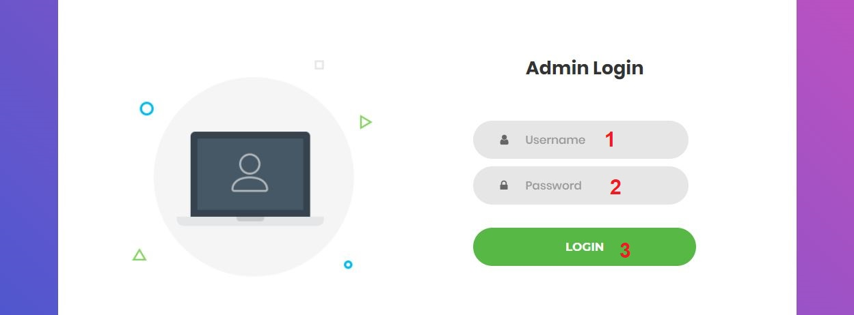

|  |  |  |  |  |  |  |
| --- | --- | --- | --- | --- | --- | --- |
| **No** | **Name** | **Type** | **Validation** | **Event** | **Description** | **Status** |
| 1 | txtUsername | Textbox | -Not null  -Min length:5  -Max length:20 | Focus | Input username | Enable |
| 2 | txtPassword | Textbox (password) | -Not null  -Min length:6  -Max length:20 | Focus | Input password | Enable |
| 3 | btnSubmit | Button |  | Click | Click to login | Enable |

**Source code:**

**Controller:**

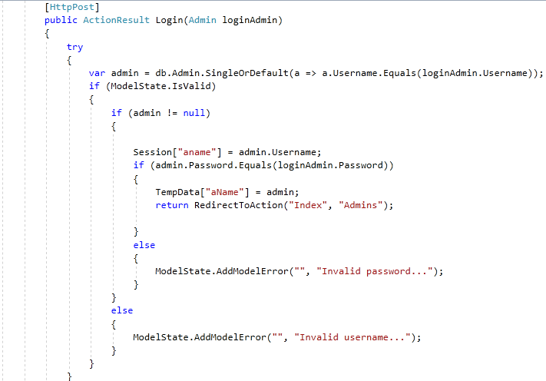

**View:**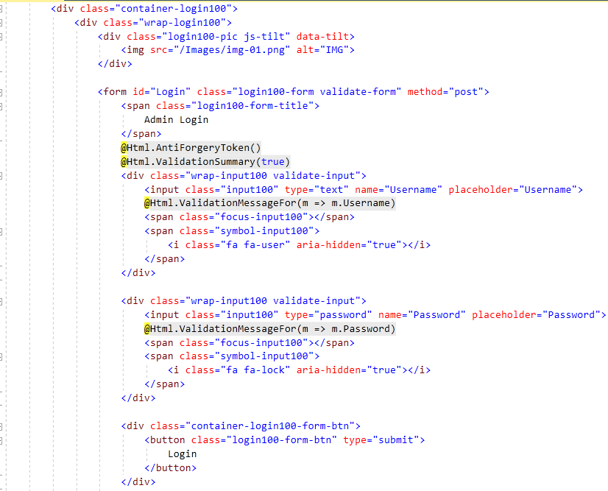

* 1. **Logout:** notification will appear when admin click logout button



|  |  |  |  |  |  |  |
| --- | --- | --- | --- | --- | --- | --- |
| **No** | **Name** | **Type** | **Validation** | **Event** | **Description** | **Status** |
| 1 | btnOk | Button |  | Click | Click to logout | Enable |
| 2 | btnCancel | Button |  | Click | Click to return | Enable |

**Source code:**

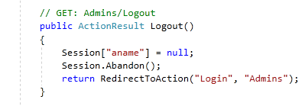

* 1. **Change Password Page:** Admin can change password here

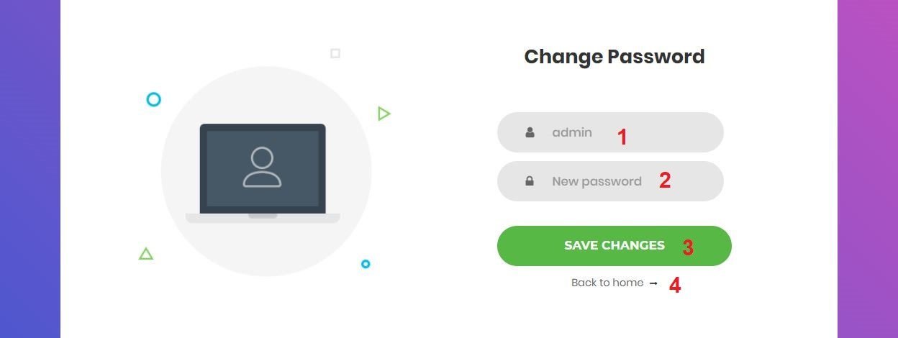

|  |  |  |  |  |  |  |
| --- | --- | --- | --- | --- | --- | --- |
| **No** | **Name** | **Type** | **Validation** | **Event** | **Description** | **Status** |
| 1 | Username | Textbox (Read only) |  | Focus | Username |  |
| 2 | New Password | Textbox (password) | - Not null  - Min length:6  - Max length:20 | Focus | Input new password | Enable |
| 3 | Save changes | Button |  | Click | Click to change password | Enable |
| 4 | Back to Home | Hyperlink |  | Click | Click to return home page | Enable |

**Source code:**

**Controller:**

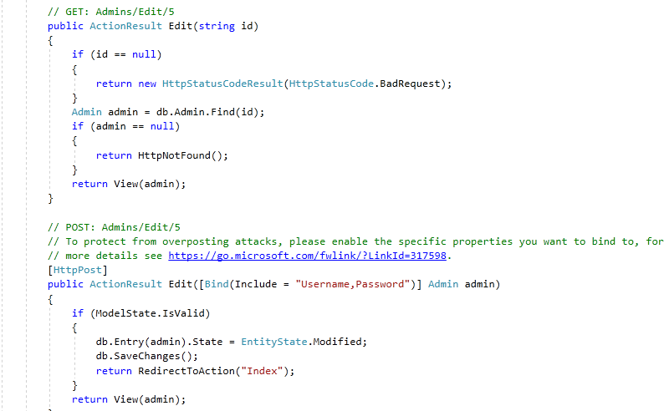

**View:**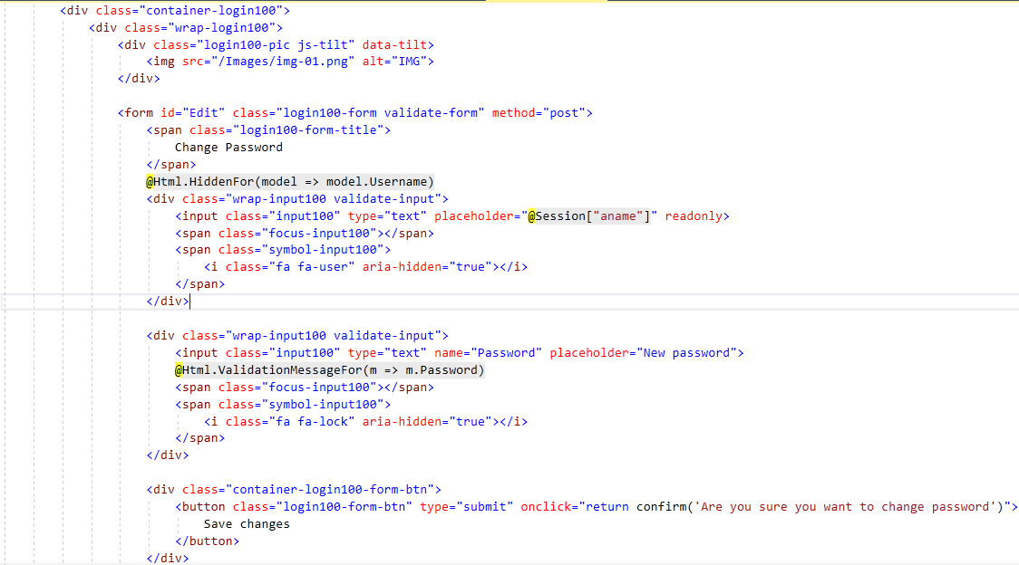

* 1. **Home Page:** has navigation bar links to all manage pages

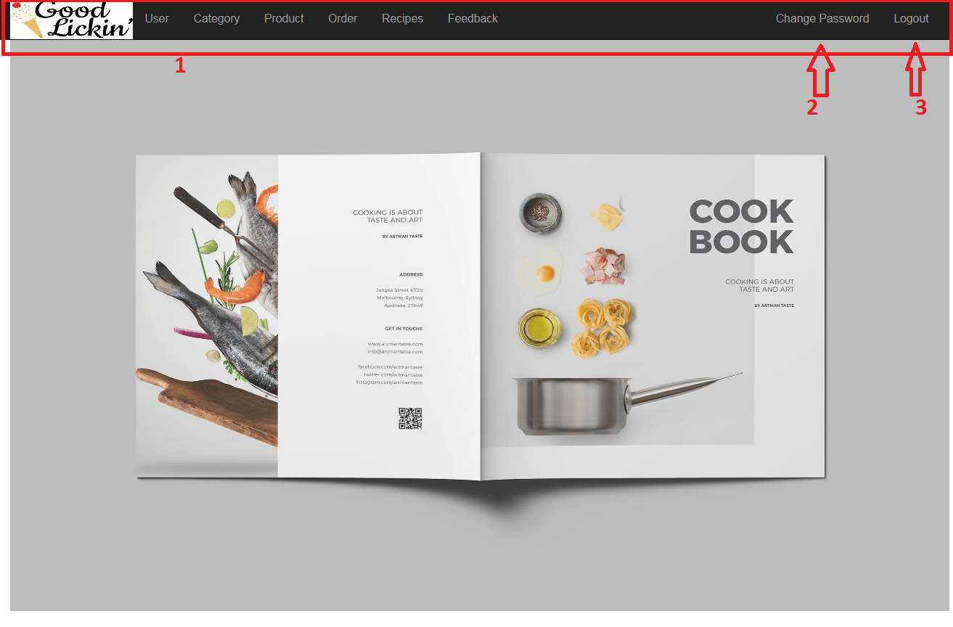

|  |  |  |  |  |  |  |
| --- | --- | --- | --- | --- | --- | --- |
| **No** | **Name** | **Type** | **Validation** | **Event** | **Description** | **Status** |
| 1 | Navigation Bar | Hyperlink |  | Click | Click to go to management pages | Enable |
| 2 | Change Password | Hyperlink |  | Click | Click to go to change password page | Enable |
| 3 | Logout | Hyperlink |  | Click | Click to logout | Enable |

**Source code:**

**FrontEnd:**

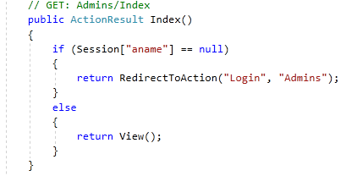

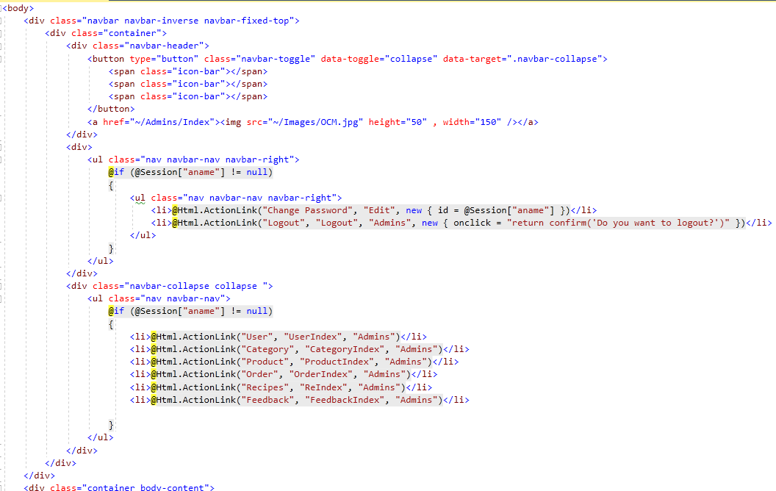

* 1. **Category Management Page:** Admin can manage product here

**2.5.1. Add new Category:** Create category form for admin

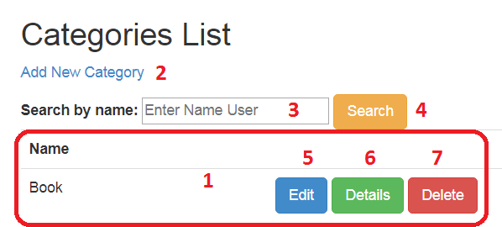

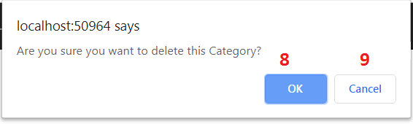

|  |  |  |  |  |  |  |
| --- | --- | --- | --- | --- | --- | --- |
| **No** | **Name** | **Type** | **Validation** | **Event** | **Description** | **Status** |
| 1 | Category List | Table |  |  | List of Category | Enable |
| 2 | Add New Category | Hyperlink |  | Click | Click to go to add new category page | Enable |
| 3 | txtSearch | Textbox |  | Click | Input name of Search to search | Enable |
| 4 | btnFilter | Button |  | Click | Click to search product | Enable |
| 5 | Edit | Hyperlink |  | Click | Click to go to edit category page | Enable |
| 6 | Details | Hyperlink |  | Click | Click to go to product details page | Enable |
| 7 | Delete | Hyperlink |  | Click | Process to delete product | Enable |
| 8 | btnOk | Button |  | Click | Click to delete product | Enable |
| 9 | btnCancel | Button |  | Click | Click to return | Enable |

**Source code:**

**Controller:**

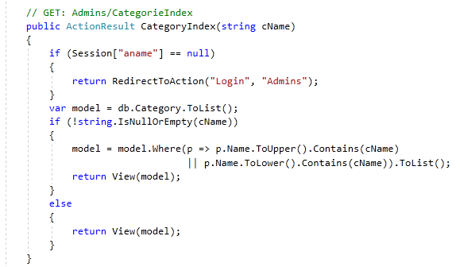

**View:**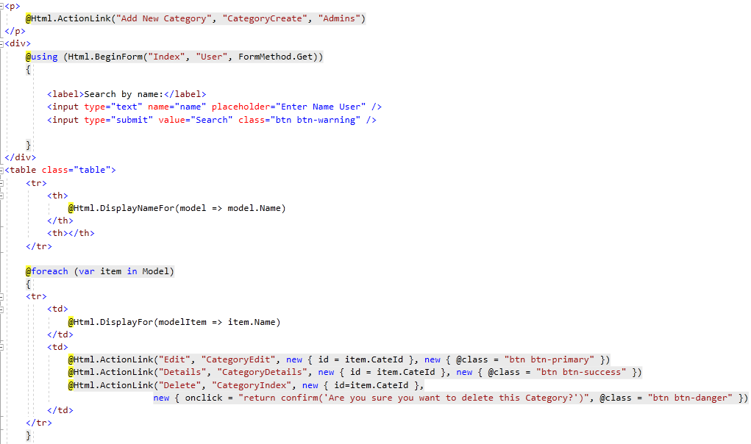

* + 1. **Add new Category:** Create category form for admin

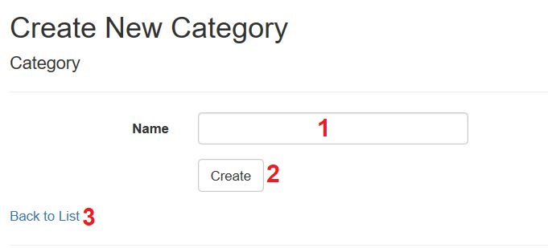

|  |  |  |  |  |  |  |
| --- | --- | --- | --- | --- | --- | --- |
| **No** | **Name** | **Type** | **Validation** | **Event** | **Description** | **Status** |
| 1 | txtCateName | Textbox | - Not null - Max length:50 | Focus | Input category name | Enable |
| 2 | btnSubmit | Button |  | Click | Click to add new category | Enable |
| 3 | Back to list | Hyperlink |  | Click | Click to go back category list | Enable |

**Source code:**

**Controller:**

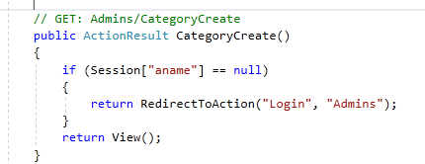**’**

**View:**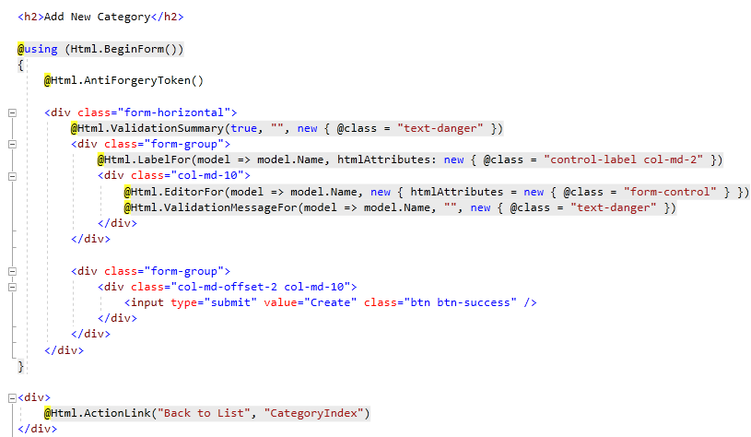

* + 1. **Edit Category:** Edit category form for admin

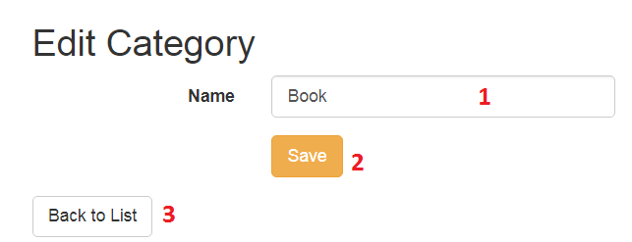

|  |  |  |  |  |  |  |
| --- | --- | --- | --- | --- | --- | --- |
| **No** | **Name** | **Type** | **Validation** | **Event** | **Description** | **Status** |
| 1 | txtCateName | Textbox | - Not null - Max length:50 | Focus | Input to edit category name | Enable |
| 2 | btnSubmit | Button |  | Click | Click to edit category | Enable |
| 3 | Back to list | Hyperlink |  | Click | Click to go back category list | Enable |

**Source code:**

**Controller:**

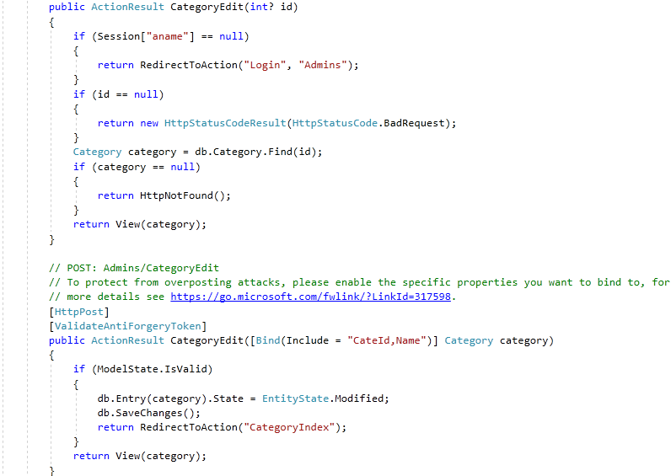

**View:**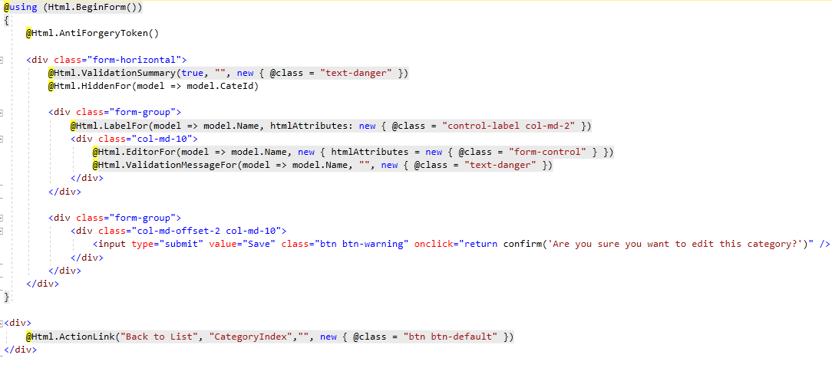

* + 1. **Details of Category:** This page display details of a category

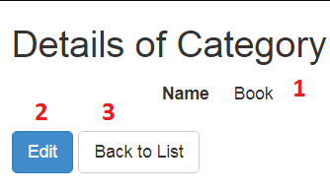

|  |  |  |  |  |  |  |
| --- | --- | --- | --- | --- | --- | --- |
| **No** | **Name** | **Type** | **Validation** | **Event** | **Description** | **Status** |
| 1 | txtCateName | Textbox  (Read only) |  |  | Category’s name | Enable |
| 2 | Edit | Hyperlink |  | Click | Click to go to edit category page | Enable |
| 3 | Back to list | Hyperlink |  | Click | Click to go back category list | Enable |

**Source code:**

**Controller:**

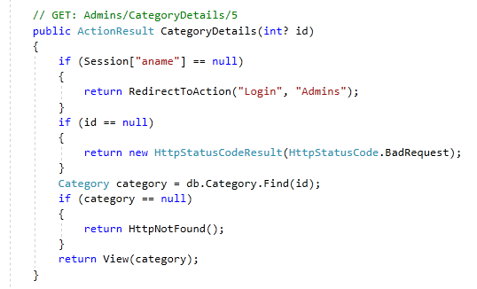

**View:**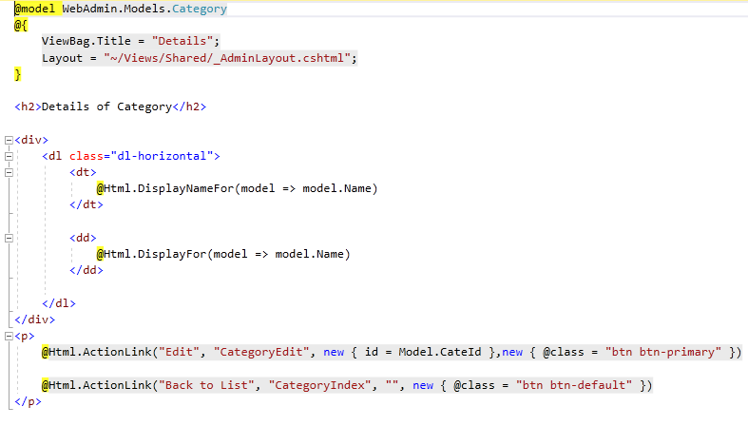

* 1. **Product Management Page:** Admin can manage product here
     1. **Manage Product List:** Display list of product, admin can create, view details, edit or delete a product from here.

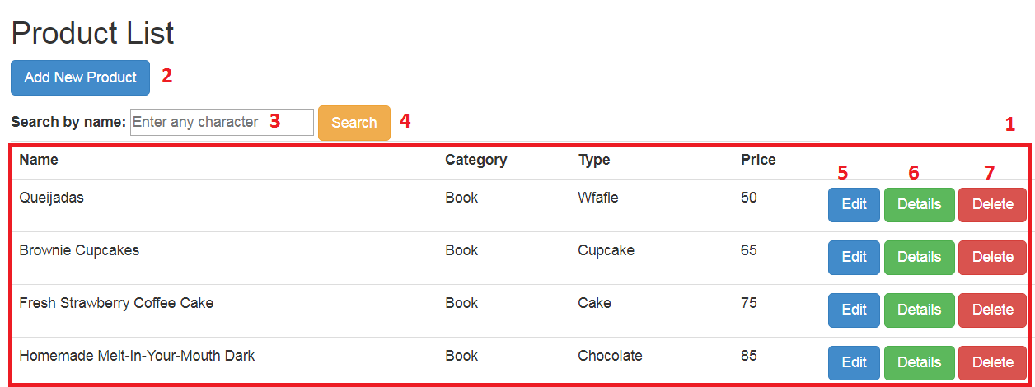

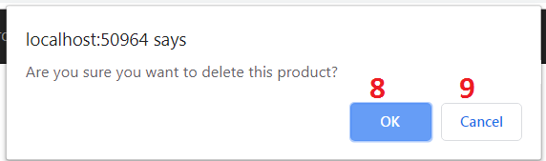

|  |  |  |  |  |  |  |
| --- | --- | --- | --- | --- | --- | --- |
| **No** | **Name** | **Type** | **Validation** | **Event** | **Description** | **Status** |
| 1 | Product List | Table |  |  | List of products | Enable |
| 2 | Add New | Hyperlink |  | Click | Click to go to add new product page | Enable |
| 3 | txtSearch | Textbox |  | Click | Input name of product to search | Enable |
| 4 | btnFilter | Button |  | Click | Click to search product | Enable |
| 5 | Edit | Hyperlink |  | Click | Click to go to edit product page | Enable |
| 6 | Details | Hyperlink |  | Click | Click to go to product details page | Enable |
| 7 | Delete | Hyperlink |  | Click | Process to delete product | Enable |
| 8 | btnOk | Button |  | Click | Click to delete product | Enable |
| 9 | btnCancel | Button |  | Click | Click to return | Enable |

**Source code:**

**Controller:**

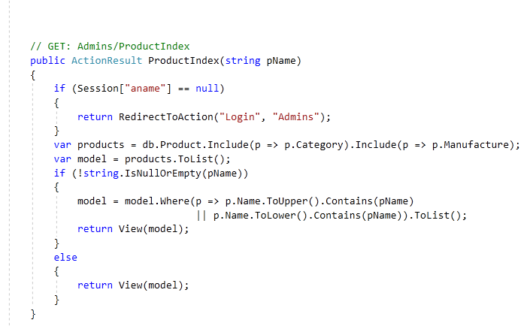

**View:**

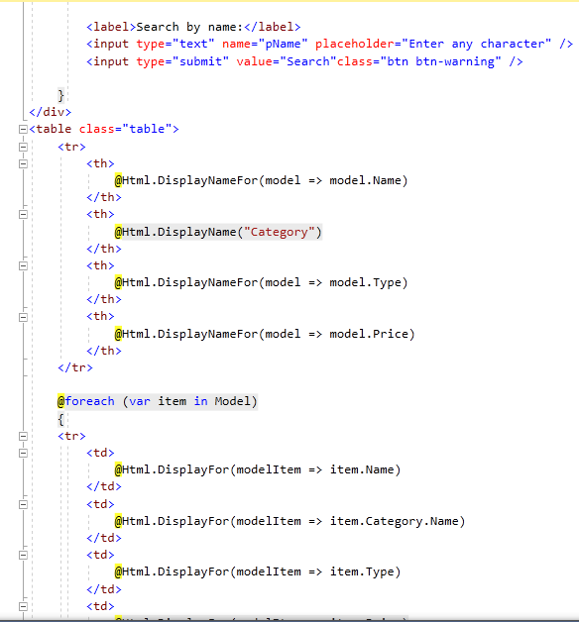

* + 1. **Add new Product:** Create product form for admin

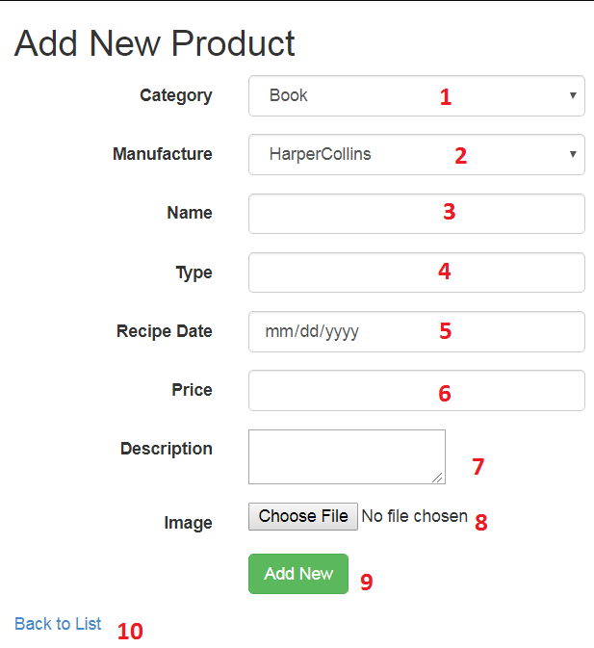

|  |  |  |  |  |  |  |
| --- | --- | --- | --- | --- | --- | --- |
| **No** | **Name** | **Type** | **Validation** | **Event** | **Description** | **Status** |
| 2 | ddCategory | Dropdown List | Not Null | Focus | Choose name of category | Enable |
| 1 | ddManufacture | Dropdown List | Not Null | Focus | Choose name of manufacture | Enable |
| 3 | txtProductName | Textbox | - Not null - Max length:50 | Focus | Input product name | Enable |
| 4 | txtType | Textbox | - Not null - Max length:50 | Focus | Input product type | Enable |
| 5 | Date | Calendar | Not Null | Focus | Input product recipe date | Enable |
| 6 | txtPrice | Textbox | - Not null - From 1 to 10000 | Focus | Input product price | Enable |
| 7 | txtDescription | Textbox | - Not null - Max length:1000 | Focus | Input product description | Enable |
| 8 | fuImage | File Upload | Not null | Focus | Upload product image | Enable |
| 9 | btnSubmit | Button |  | Click | Click to add new product | Enable |
| 10 | Back to List | Hyperlink |  | Click | Click to return product list | Enable |

**Source code:**

**Controller:**

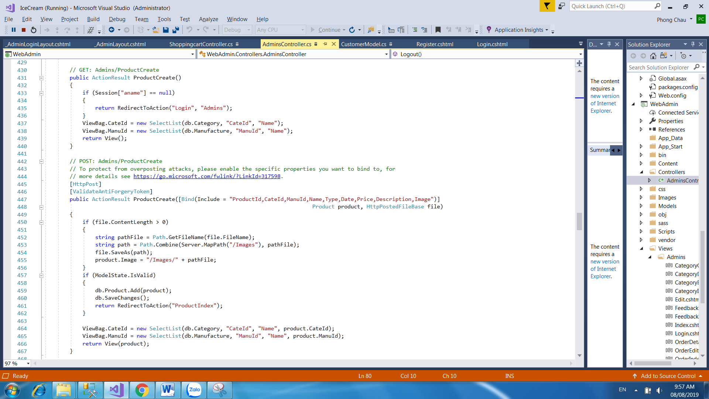

**View:**

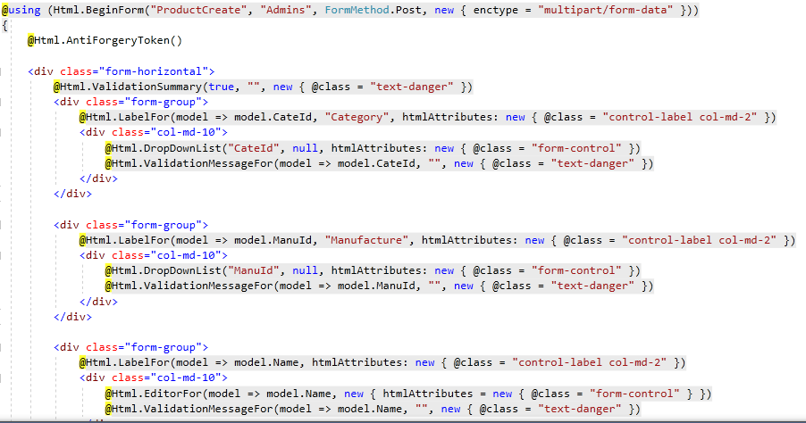

* + 1. **Product Details:** This page display details of a product

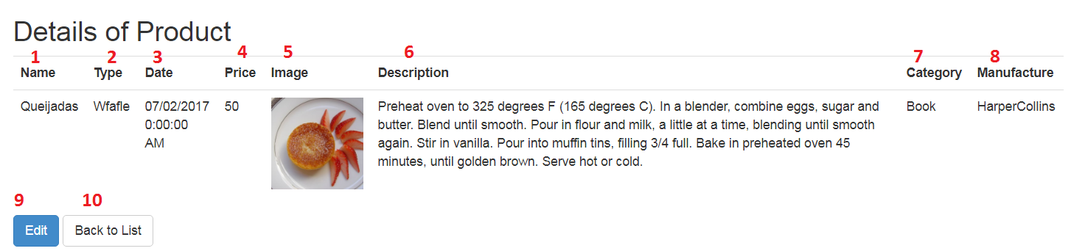

|  |  |  |  |  |  |  |
| --- | --- | --- | --- | --- | --- | --- |
| **No** | **Name** | **Type** | **Validation** | **Event** | **Description** | **Status** |
| 1 | Product Name | Textbox (Read only) |  |  | Product’s name | Enable |
| 2 | Type | Textbox (Read only) |  |  | Product’s type | Enable |
| 3 | Date | Calendar (Read only) |  |  | Product’s recipe date | Enable |
| 4 | Price | Textbox (Read only) |  |  | Product’s price | Enable |
| 5 | Image | Image (Read only) |  |  | Product’s image | Enable |
| 6 | Description | Textbox (Read only) |  |  | Product’s description | Enable |
| 7 | Category Name | Dropdown List |  |  | Category’s Name | Enable |
| 8 | Manufacture Name | Dropdown List |  |  | Manufacture’s Name | Enable |
| 9 | Edit | Hyperlink |  | Click | Click to go to edit product page | Enable |
| 10 | Back to List | Hyperlink |  | Click | Click to return product list | Enable |

**Source code:**

**Controller:**

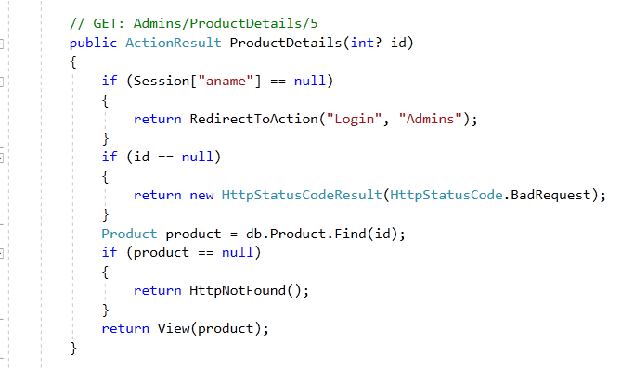

**View:**

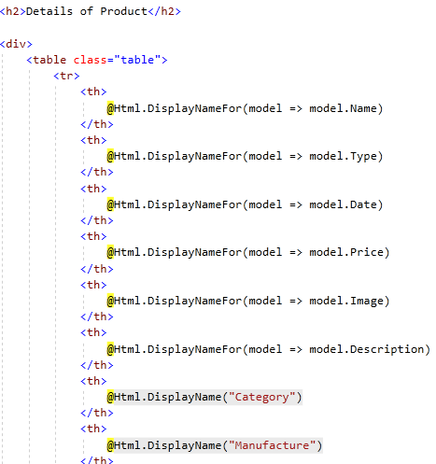

* + 1. **Edit Product:** Edit product form for admin

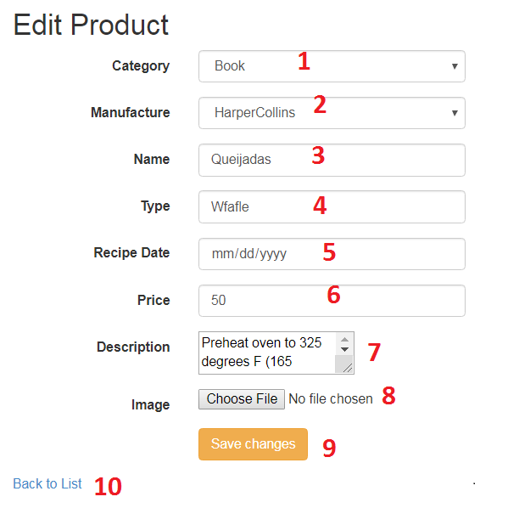

|  |  |  |  |  |  |  |
| --- | --- | --- | --- | --- | --- | --- |
| **No** | **Name** | **Type** | **Validation** | **Event** | **Description** | **Status** |
| 2 | ddCategory | Dropdown List | Not Null | Focus | Choose name of category | Enable |
| 1 | ddManufacture | Dropdown List | Not Null | Focus | Choose name of manufacture | Enable |
| 3 | txtProductName | Textbox | - Not null - Max length:50 | Focus | Input product name | Enable |
| 4 | txtType | Textbox | - Not null - Max length:50 | Focus | Input product type | Enable |
| 5 | Date | Calendar | Not Null | Focus | Input product recipe date | Enable |
| 6 | txtPrice | Textbox | - Not null - From 1 to 10000 | Focus | Input product price | Enable |
| 7 | txtDescription | Textbox | - Not null - Max length:1000 | Focus | Input product description | Enable |
| 8 | fuImage | File Upload | Not null | Focus | Upload product image | Enable |
| 9 | btnSaveChanges | Button |  | Click | Click to edit product | Enable |
| 10 | Back to List | Hyperlink |  | Click | Click to return product list | Enable |

**Source code:**

**Controller:**

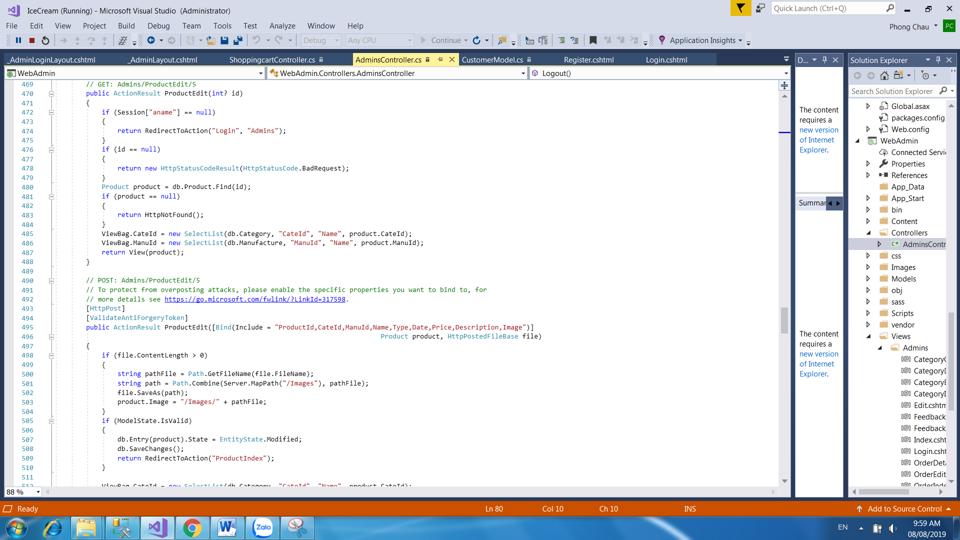

**View:**

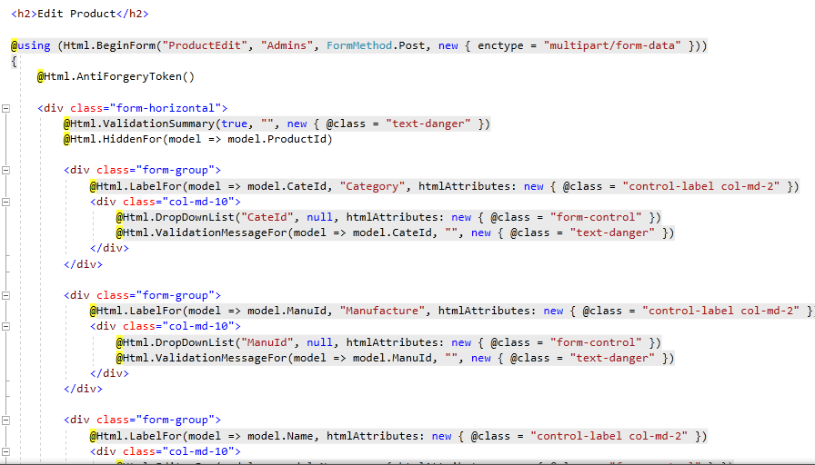

* 1. **User Management Page:** Admin can manage user here
     1. **Manage User List:** Display list of user, admin can create, view details user from here

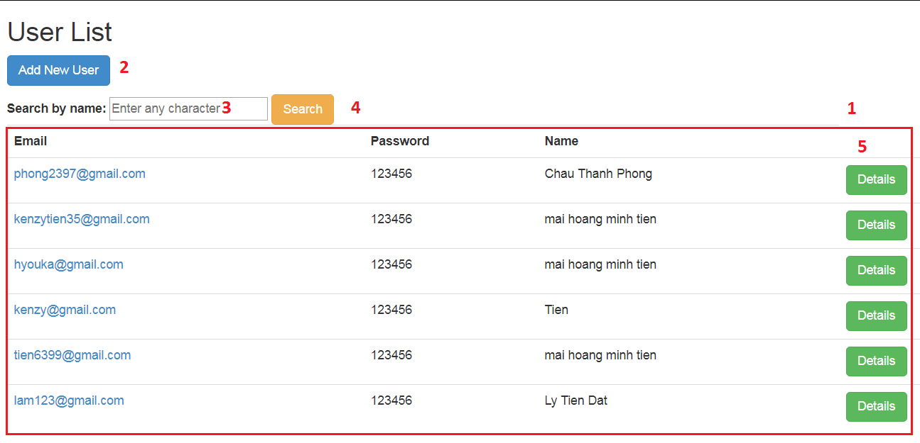

|  |  |  |  |  |  |  |
| --- | --- | --- | --- | --- | --- | --- |
| **No** | **Name** | **Type** | **Validation** | **Event** | **Description** | **Status** |
| 1 | User List | Table |  |  | List of user | Enable |
| 2 | Add New | Hyperlink |  | Click | Click to go to add new user page | Enable |
| 3 | txtSearch | Textbox |  | Click | Input name of user to search | Enable |
| 4 | btnFilter | Button |  | Click | Click to search user | Enable |
| 5 | Details | Hyperlink |  | Click | Click to go to user details page | Enable |

**Source code:**

**Controller:**

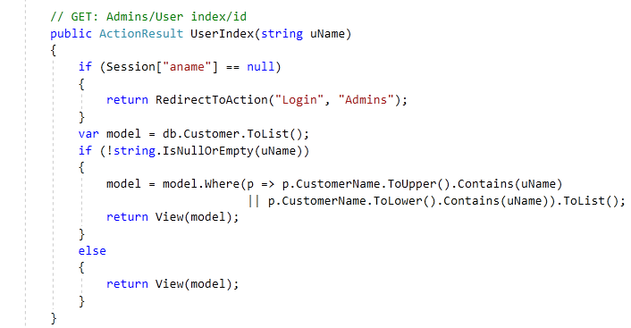

**View:**

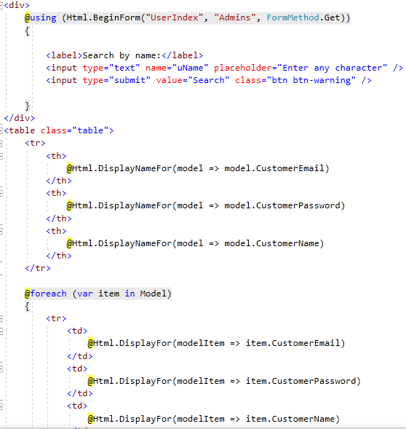

* + 1. **Add New User:** Create user form for admin

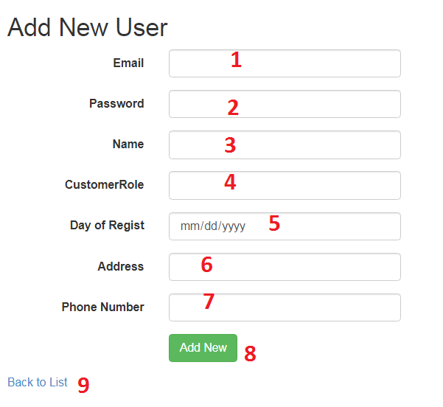

|  |  |  |  |  |  |  |
| --- | --- | --- | --- | --- | --- | --- |
| **No** | **Name** | **Type** | **Validation** | **Event** | **Description** | **Status** |
| 1 | txtEmail | Textbox | - Not null -DataType EmailAddress | Focus | Input email | Enable |
| 2 | txtPassword | Textbox | - Not null - Max length:50 | Focus | Input password | Enable |
| 3 | txtName | Textbox | - Not null - Max length:50 | Focus | Input user’s full name | Enable |
| 4 | txtRole | Textbox |  | Focus | Input value role member | Enable |
| 5 | txtDayofRegist | Calendar |  | Focus | Input user’s register | Enable |
| 6 | txtAddress | Textbox | - Not null - Max length:50 | Focus | Input user’s address | Enable |
| 7 | txtPhone | Textbox | - Not null - Max length:15 | Focus | Input user’s phone number | Enable |
| 8 | btnSubmit | Button |  | Click | Click to add new user | Enable |
| 9 | Back to List | Hyperlink |  | Click | Click to return user list | Enable |

**Source code:**

**Controller:**

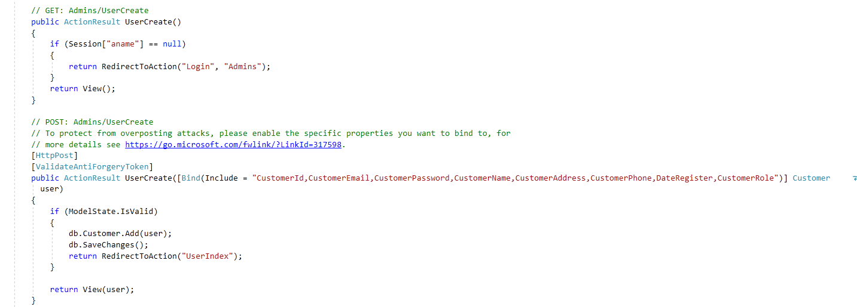

**View:**

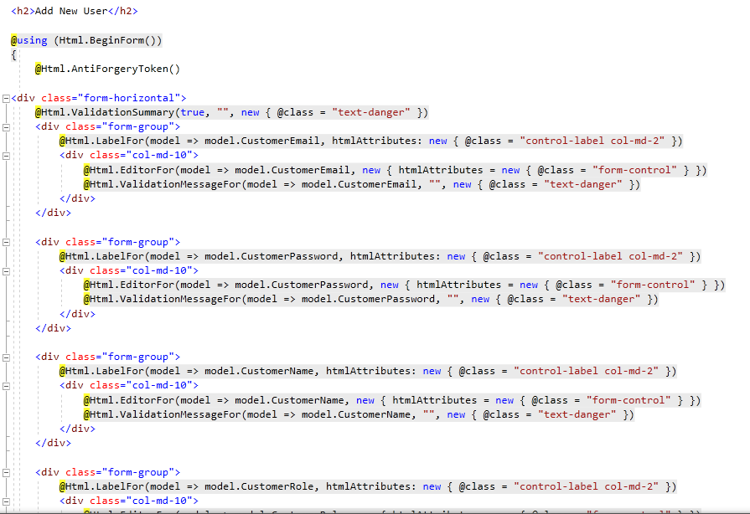

* + 1. **User Details:** This page display details of a user

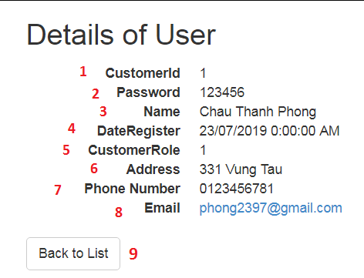

|  |  |  |  |  |  |  |
| --- | --- | --- | --- | --- | --- | --- |
| **No** | **Name** | **Type** | **Validation** | **Event** | **Description** | **Status** |
| 1 | txtCustomerId | Textbox (Read only) |  | Focus | Username | Enable |
| 2 | txtPassword | Textbox (Read only) |  | Focus | Password | Enable |
| 3 | txtName | Textbox (Read only) |  | Focus | User’s full name | Enable |
| 4 | txtDayofRegist | Textbox (Read only) |  | Focus | User’s Regist | Enable |
| 5 | txCustomerRole | Textbox (Read only) |  | Focus | User’s Role | Enable |
| 6 | txtAddress | Textbox (Read only) |  | Focus | User’s address | Enable |
| 7 | txtPhone | Textbox (Read only) |  | Focus | User’s phone number | Enable |
| 8 | txtEmail | Textbox (Read only) |  | Focus | User’s email | Enable |
| 9 | Back to List | Hyperlink |  | Click | Click to return user list | Enable |

**Source code:**

**Controller:**

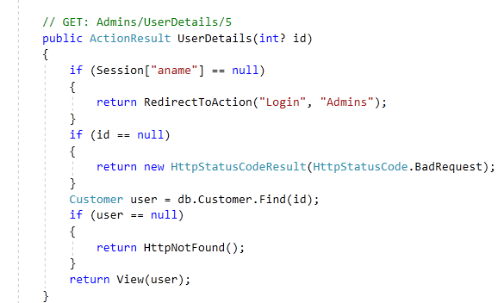

**View:**

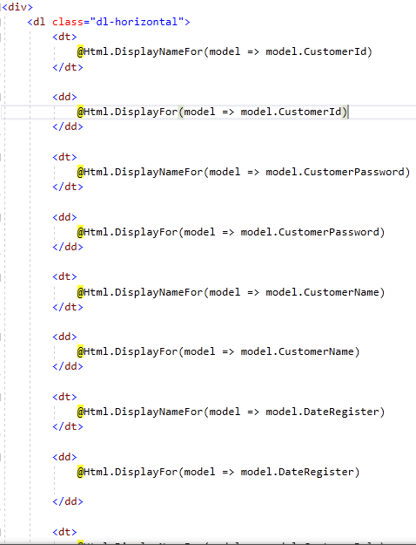

* 1. **Order Management Page:** Admin can manage order here
     1. **Manage Order List:** Display list of order, admin can view details an order from here

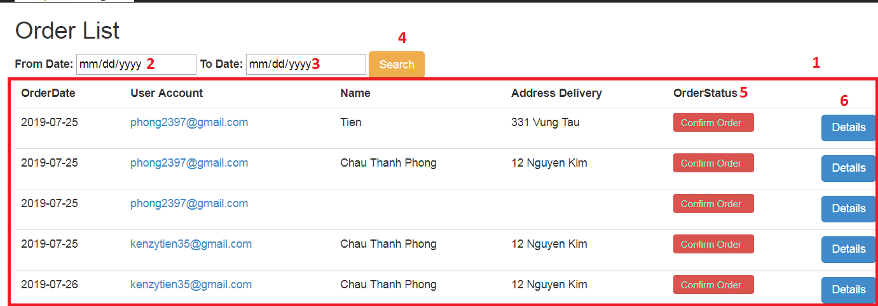

|  |  |  |  |  |  |  |
| --- | --- | --- | --- | --- | --- | --- |
| **No** | **Name** | **Type** | **Validation** | **Event** | **Description** | **Status** |
| 1 | Order List | Table |  |  | List of order | Enable |
| 2 | txtdFrom | Textbox |  | Focus | Input start date want to search | Enable |
| 3 | txtdTo | Textbox |  | Focus | Input end date want to search | Enable |
| 4 | btnFilter | Button |  | Click | Click to search order | Enable |
| 5 | BtnStatus | Button |  | Click | Click to update status order | Enable |
| 6 | Details | Hyperlink |  | Click | Click to go to order details page | Enable |

**Source code:**

**Controller:**

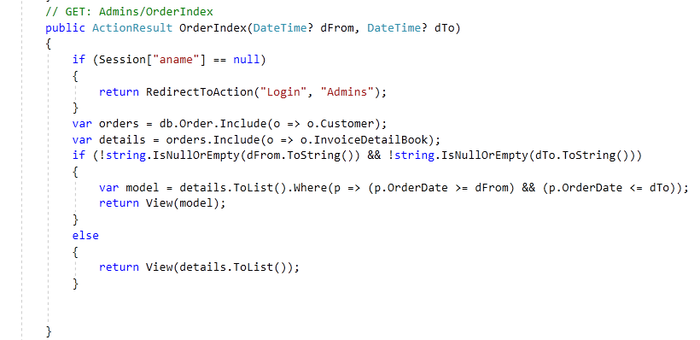

**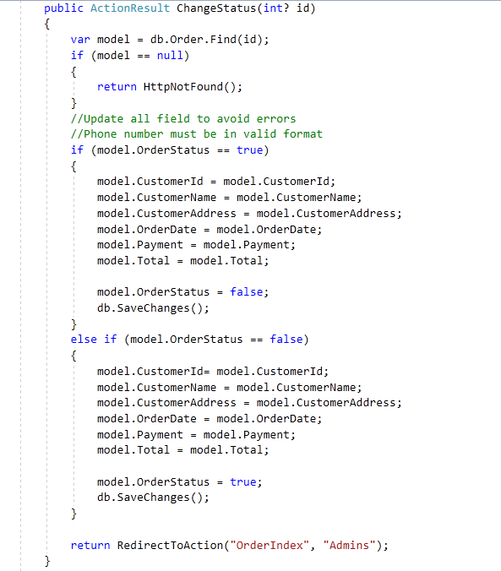****:**

**View:**

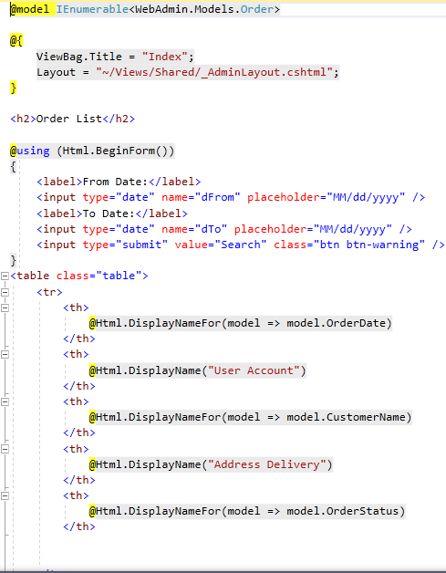

* + 1. **Order Details Page:** This page display details of an order

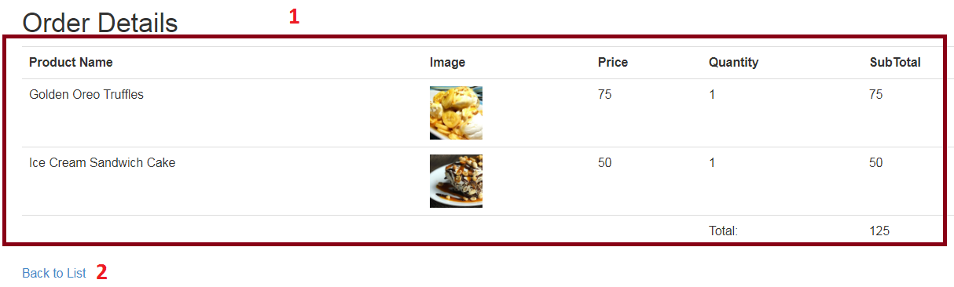

|  |  |  |  |  |  |  |
| --- | --- | --- | --- | --- | --- | --- |
| **No** | **Name** | **Type** | **Validation** | **Event** | **Description** | **Status** |
| 1 | Order Details List | Table |  |  | Order details of 1 order | Enable |
| 2 | Back to List | Hyperlink |  | Click | Click to return order list | Enable |

**Source code:**

**Controller:**

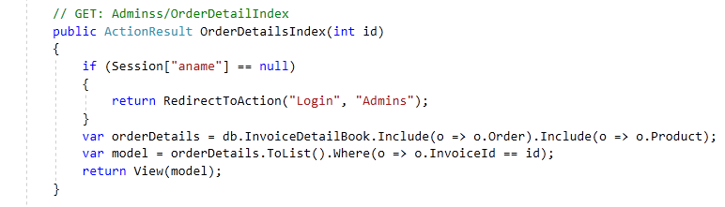

**View:**

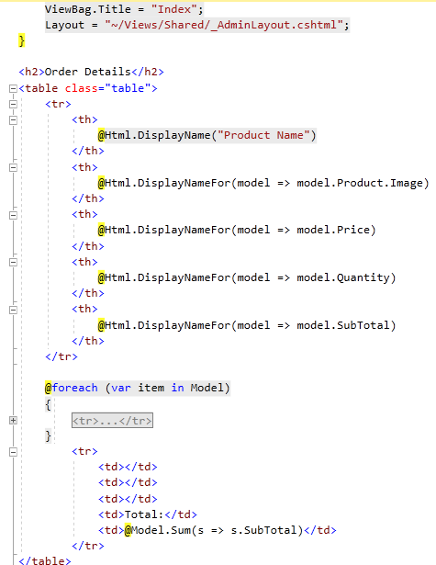

* 1. **Feedback Management Page:** Admin can manage feedback here
     1. **Feedback List:** Display list of feedback, view details, recipe from here

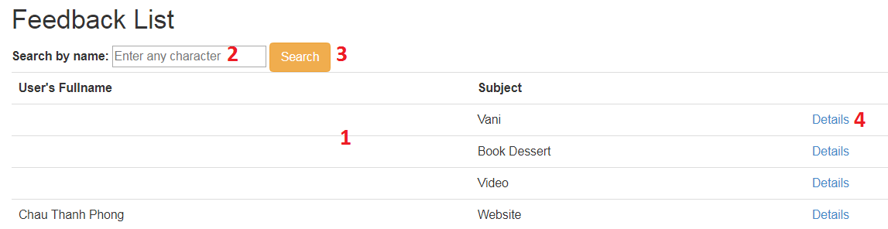

|  |  |  |  |  |  |  |
| --- | --- | --- | --- | --- | --- | --- |
| **No** | **Name** | **Type** | **Validation** | **Event** | **Description** | **Status** |
| 1 | Feedback List | Table |  |  | List of feedbacks | Enable |
| 2 | txtSearch | Textbox |  | Focus | Input user’s full name to search feedback | Enable |
| 3 | btnFilter | Button |  | Click | Click to search feedback | Enable |
| 4 | Details | Hyperlink |  | Click | Click to go to details & delete feedback page | Enable |

**Source code:**

**Controller:**

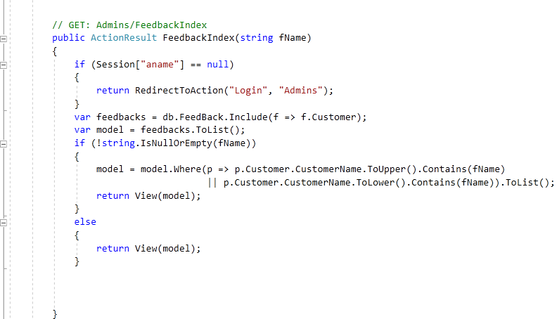

**View:**

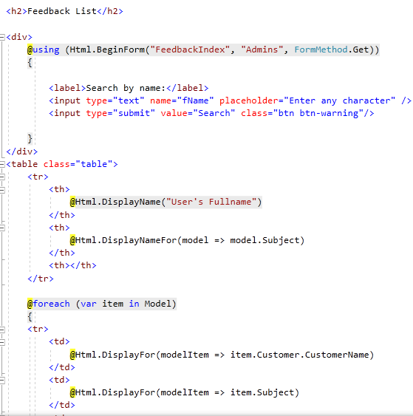

* + 1. **Details Feedback:** Display details of a feedback’s user.

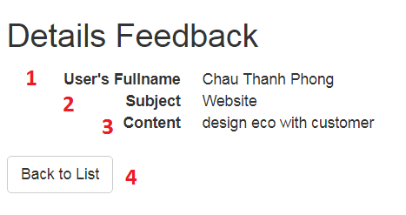

|  |  |  |  |  |  |  |
| --- | --- | --- | --- | --- | --- | --- |
| **No** | **Name** | **Type** | **Validation** | **Event** | **Description** | **Status** |
| 1 | txtUsername | Textbox (Read only) |  | Focus | Username | Enable |
| 2 | txtSubject | Textbox (Read only) |  | Focus | Feedback’s Subject | Enable |
| 3 | txtContent | Textbox (Read only) |  | Focus | Feedback’s Content | Enable |
| 4 | Back to List | Hyperlink |  | Click | Click to return feedback list | Enable |

**Source code**

**Controller:**

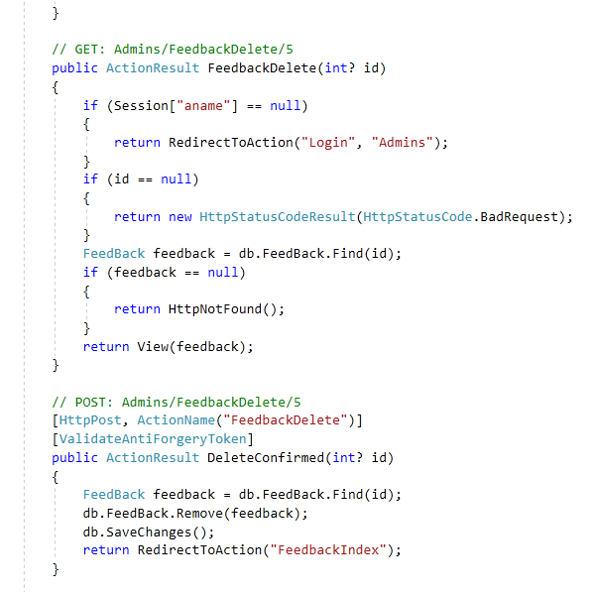

**View:**

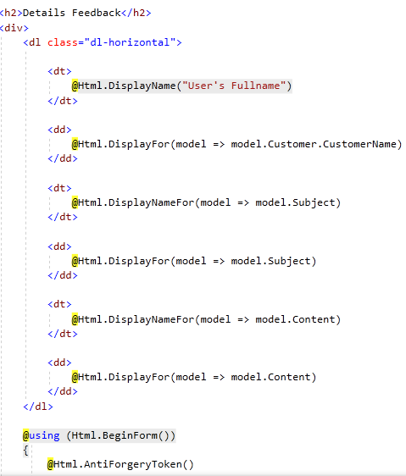

* 1. **Recipes Manage Page:** Admin can manage recipe in here
     1. **Recipes List:** Display list of Recipe, admin can view details,edit or delete a feedback from here

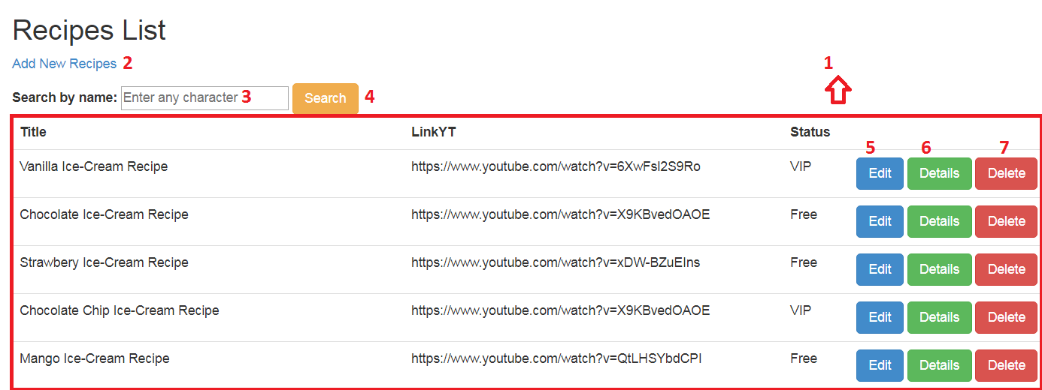

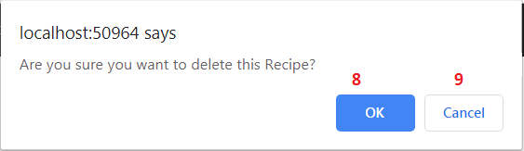

|  |  |  |  |  |  |  |
| --- | --- | --- | --- | --- | --- | --- |
| **No** | **Name** | **Type** | **Validation** | **Event** | **Description** | **Status** |
| 1 | Recipe List | Table |  |  | List of Recipe | Enable |
| 2 | Add New | Hyperlink |  | Click | Click to go to add new recipes page | Enable |
| 3 | txtSearch | Textbox |  | Click | Input name of recipe to search | Enable |
| 4 | btnFilter | Button |  | Click | Click to search recipe | Enable |
| 5 | Edit | Hyperlink |  | Click | Click to go to edit recipe page | Enable |
| 6 | Details | Hyperlink |  | Click | Click to go to recipe details page | Enable |
| 7 | Delete | Hyperlink |  | Click | Process to delete recipe | Enable |
| 8 | btnOk | Button |  | Click | Click to delete recipe | Enable |
| 9 | btnCancel | Button |  | Click | Click to return | Enable |

**Source code:**

**Controller:**

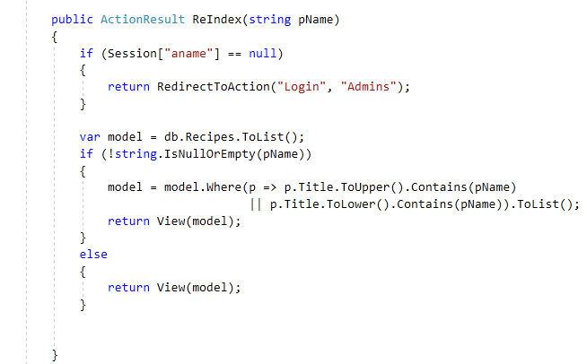

**View:**

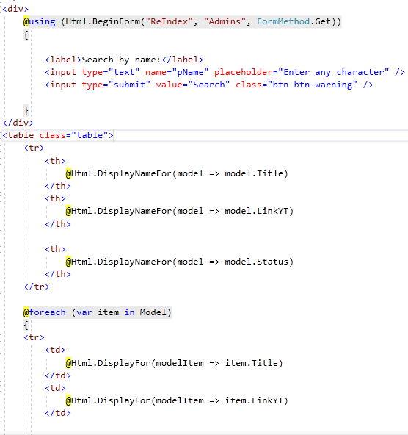

* + 1. **Add new Recipes:** Create Recipes form for admin

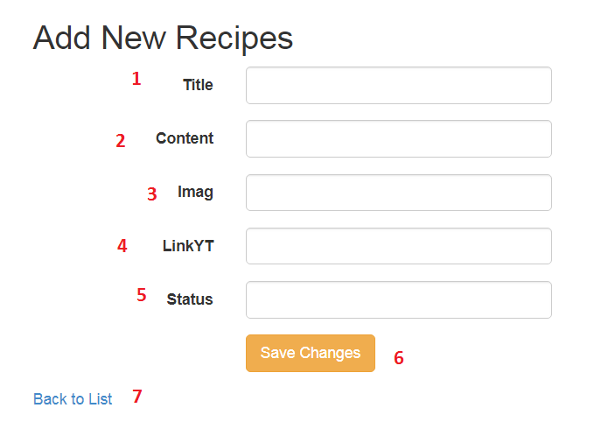

|  |  |  |  |  |  |  |
| --- | --- | --- | --- | --- | --- | --- |
| **No** | **Name** | **Type** | **Validation** | **Event** | **Description** | **Status** |
| 1 | txtTitle | Textbox |  | Focus | Input Title | Enable |
| 2 | txtContent | Textbox |  | Focus | Input Content | Enable |
| 3 | Imag | Textbox |  | Focus | Choose File Image of recipe | Enable |
| 4 | txtLinkYT | Textbox |  | Focus | Input Link | Enable |
| 5 | txtStatus | TextBox |  | Focus | Input Status of Recipe | Enable |
| 6 | btnSubmit | Button |  | Click | Click to add new recipe | Enable |
| 7 | Back to List | Hyperlink |  | Click | Click to return recipe list | Enable |

**Source code**

**Controller:**

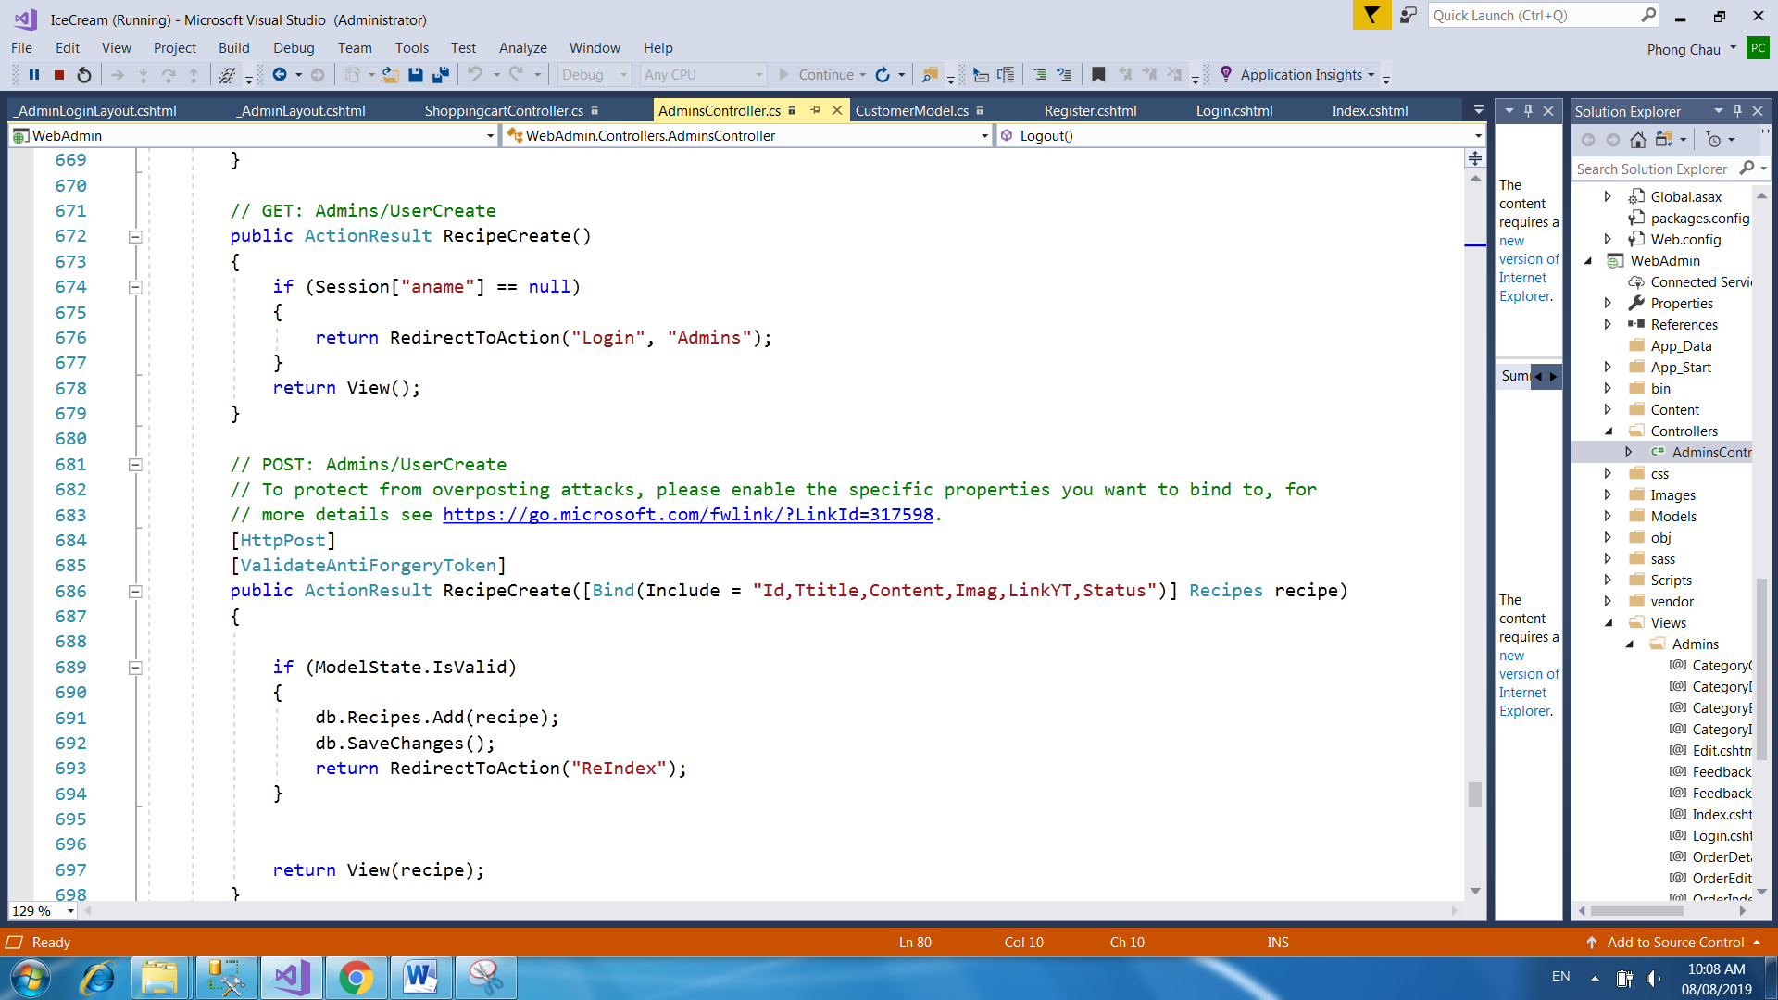

**View:**

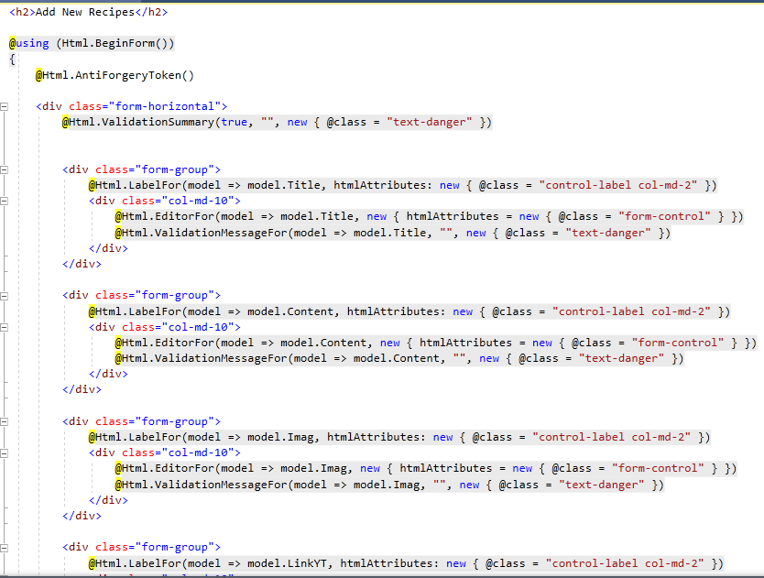

* + 1. **Edit Recipes:** Edit Recipe form for admin

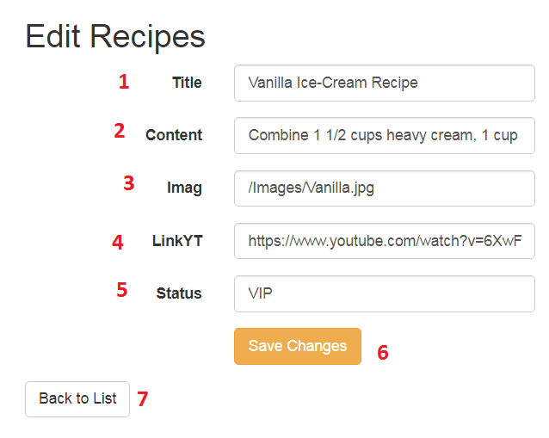

|  |  |  |  |  |  |  |
| --- | --- | --- | --- | --- | --- | --- |
| **No** | **Name** | **Type** | **Validation** | **Event** | **Description** | **Status** |
| 1 | txtTitle | Textbox  (Read Only) |  | Focus | Input Title | Enable |
| 2 | txtContent | Textbox  (Read Only) |  | Focus | Input Content | Enable |
| 3 | Imag | Textbox |  | Focus | Input link Image | Enable |
| 4 | txtLinkYT | Textbox  (Read Only) |  | Focus | Input Link | Enable |
| 5 | txtStatus | Textbox  (Read Only) |  | Focus | Input Status of Recipe | Enable |
| 8 | btnSubmit | Button |  | Click | Click to add new recipe | Enable |
| 9 | Back to List | Hyperlink |  | Click | Click to return recipe list | Enable |

**Source code:**

**Controller:**

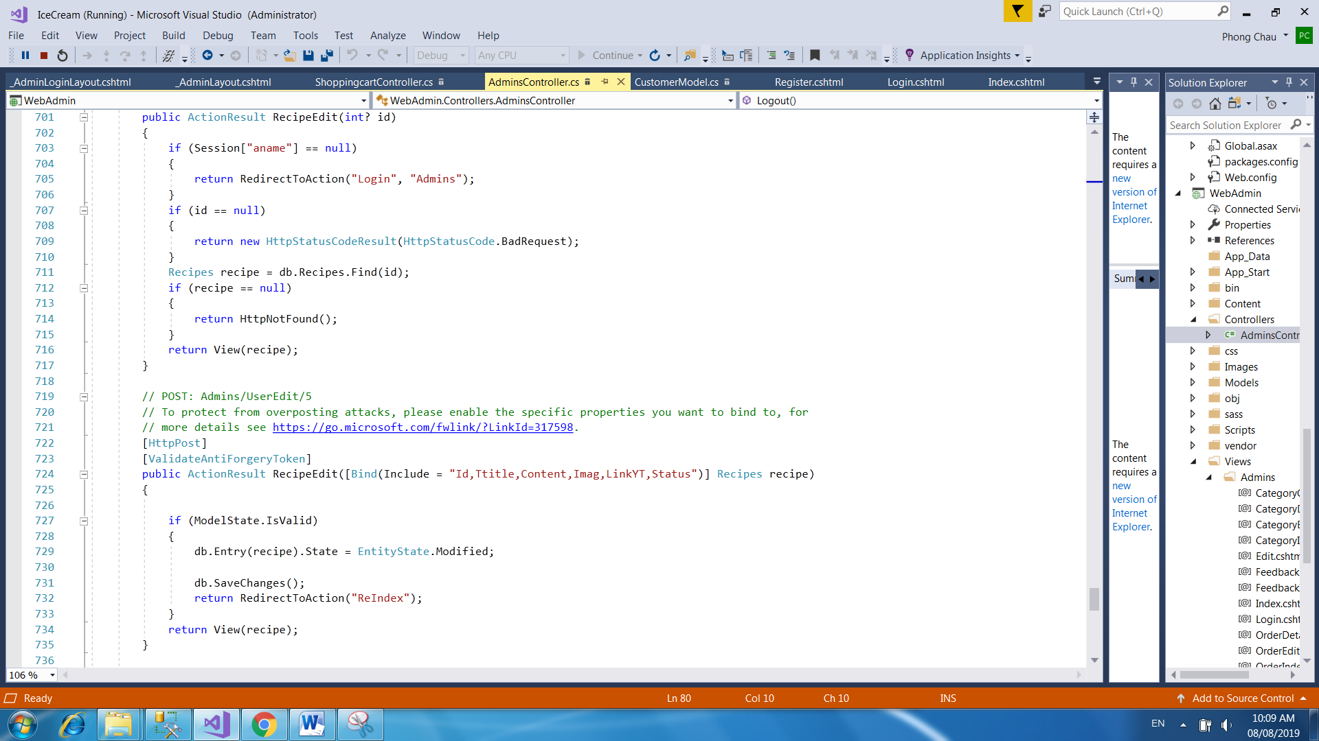

**View:**

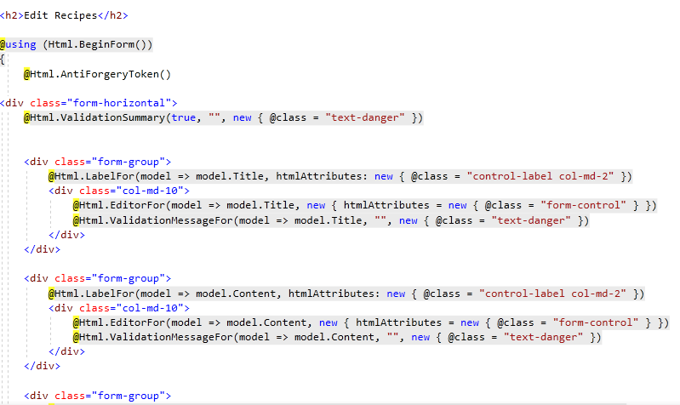

* + 1. **Details of Recipes:** This page display details of a Recipes

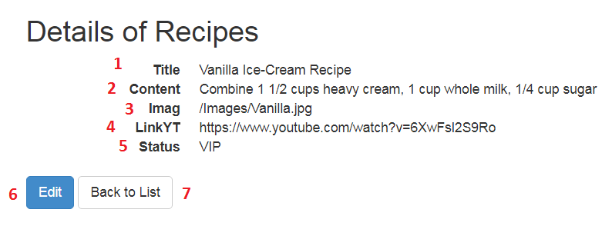

|  |  |  |  |  |  |  |
| --- | --- | --- | --- | --- | --- | --- |
| **No** | **Name** | **Type** | **Validation** | **Event** | **Description** | **Status** |
| 1 | txtTitle | Textbox  (Read Only) |  | Focus | Title | Enable |
| 2 | txtContent | Textbox  (Read Only) |  | Focus | Content | Enable |
| 3 | Imag | Textbox |  | Focus | Link Image | Enable |
| 4 | txtLinkYT | Textbox  (Read Only) |  | Focus | Link | Enable |
| 5 | txtStatus | Textbox  (Read Only) |  | Focus | Status of Recipe | Enable |
| 6 | Edit | Hyperlink |  | Click | Click to return edit recipe | Enable |
| 7 | Back to List | Hyperlink |  | Click | Click to return recipe list | Enable |

**Source code:**

**Controller:**

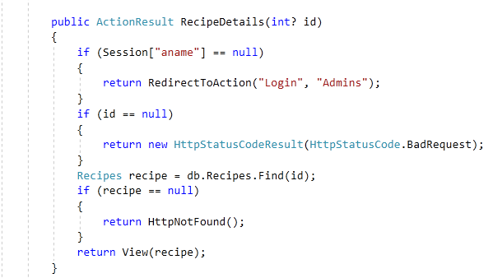

**View:**

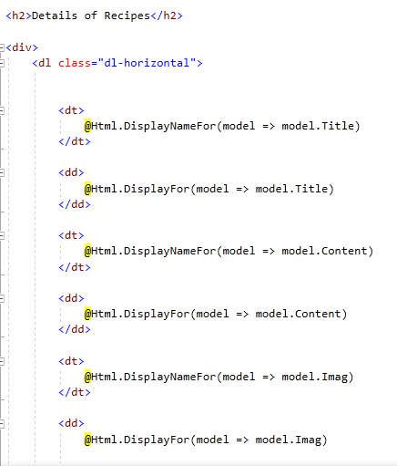

1. **SITE MAP**
2. **Back-End Site Map**

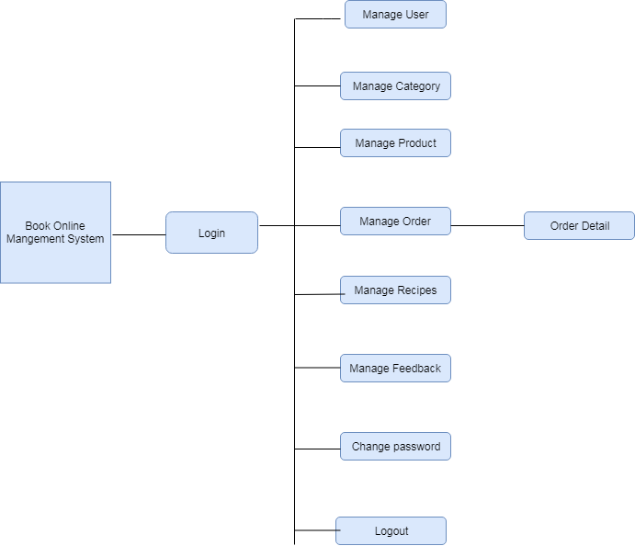

1. **Front-End Site Map**

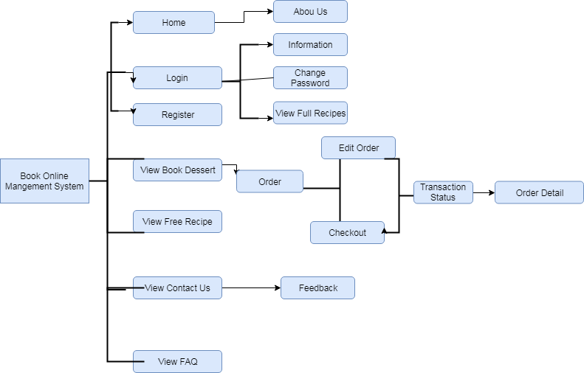

1. **TEST PLAN/TEST CASE**

|  |  |  |  |  |
| --- | --- | --- | --- | --- |
| **Test** | **What is being tested** | **How** | **Test data used** | **Expected Results** |
| 1 | Order of input on data entry screen | Enter data from data capture sheet into the form on the data entry screen | Data set 1 | Data entry order is the same as that on the data capture sheet |
| 2 | Validation of input | Enter typical values, boundary value, values that should be rejected | Data set 2 | Good data accepted, bad data rejected |
| 3 | Accurate calculations |  | Data set 3 | Data set 3A |
| 4 | Scaled output |  | Data set 4 | Paginated output |

1. **CHECKLIST OF VALIDATIONS**

|  |  |
| --- | --- |
| **Option** | **Validated** |
| Do all numeric variables have a default value of zero? | Yes |
| Does the administrator have all the rights to create and delete the records? | Yes |
| Are all the records properly fed into the appropriate database? | Yes |
| Have all the modules been properly integrated and are completely functional? | Yes |
| Have all the design and coding standards been followed and implemented? | Yes |
| Is the design consistent all over? | Yes |
| Is the navigation sequence correct through all the screens in the application? | Yes |
| Is exception handling mechanism implemented in all the screens? | Yes |
| Are all the program codes working? | Yes |

1. **SUBMISSION CHECKLIST**

|  |  |  |  |  |  |
| --- | --- | --- | --- | --- | --- |
| **Sr.No.** | **Particulars** | **Yes** | **No** | **NA** | **Comments** |
| 1 | Have all the modules been properly integrated and are they completely functional? | Yes |  |  |  |
| 2 | Does each unit meet its objective and purpose?  Are all the validations happening as specified in Process Design? | Yes |  |  |  |
| 3 | Have all Design and Coding standards been followed and implemented? | Yes |  |  |  |
| 4 | Is the GUI design consistent all over? | Yes |  |  |  |
| 5 | Are the codes working as per the specification? | Yes |  |  | . |
| 6 | Does the application’s functionality resolve the client problem, and satisfy his/her needs completely? | Yes |  |  |  |
| 7 | Have the hardware and software been correctly chosen? | Yes |  |  |  |
| 8 | Additional features and utilities that give value addition to the entire project. | Yes |  |  |  |

# TASK SHEET REVIEW 3

|  |  |  |  |  |  |  |  |  |
| --- | --- | --- | --- | --- | --- | --- | --- | --- |
| **Project Ref. No.:**  **Airlines Reservation System** | | **Project Title:** | **Activity Plan Prepared By:** | **Date of Preparation of Activity Plan:** | | | | |
| **Sr.No.** | **Task** | **Actual Start Date** | **Actual Days** | **Team Mate Names** | | **Status** |
| 1 | Admin Site Map | Ice Cream Shop  Management System | Bui Van Huong | 15/07/2019 | 1 | Chau Thanh Phong | | Completed |
| 2 | Client Site Map | Mai Hoang Minh Tien | | Completed |
| **Client Pages** | |  | | | | |
| 3 | Login Page | 21/07/2019 | 1 | Mai Hoang Minh Tien | | Completed |
| 4 | Dashboard Page | 1 | Bui Van Huong | | Completed |
| 5 | Register Page | 1 | Mai Hoang Minh Tien | | Completed |
| 6 | Members Page | 1 | Mai Hoang Minh Tien | | Completed |
| 7 | Change Password Page | 22/07/2019 | 5 | Mai Hoang Minh Tien | | Completed |
| 8 | Product Book Page | Chau Thanh Phong | | Completed |
| 9 | Detail Book Page | Chau Thanh Phong | | Completed |
| 10 | Shopping Cart Page | 26/07/2019 | 4 | Chau Thanh Phong | | Completed |
| 11 | Order Page | 4 | Chau Thanh Phong | | Completed |
| 12 | Detail Order Page | 2 | Chau Thanh Phong | | Completed |
| 13 | Free Recipes Page | 27/07/2019 | 1 | Ly Tien Dat | | Completed |
| 14 | Full Recipes Page | 1 | Ly Tien Dat | | Completed |
| 15 | Detail Recipes Page | 28/07/2019 | 2 | Ly Tien Dat | | Completed |
| 16 | Feedback Page | 28/07/2019 | 1 | Dang Nguyen Dan Linh | | Completed |
| 17 | FAQ Page | 29/07/2019 | 1 | Dang Nguyen Dan Linh | | Completed |
| **Admin Pages** | |  | | | | |
| 13 | Login Page | 25/07/2019 | 1 | Bui Van huong | Completed | |
| 14 | Dashboard Page | Completed | |
| 15 | Change Password Page | Completed | |
| 16 | User Page | 29/07/2019 | 2 | Chau Thanh Phong | Completed | |
| 17 | Category Page | Completed | |
| 18 | Product page | Completed | |
| 19 | Order page | Completed | |
| 20 | Recipes Page | Completed | |
| 21 | Feedback page | Completed | |

|  |  |
| --- | --- |
| **Date:** | |
| Signature of Instructor:  **MS. Le Mong Thuy** | Signature of Team Leader:  **Bui Van Huong** |